https://forge.tcsbank.ru/case/5424085/info
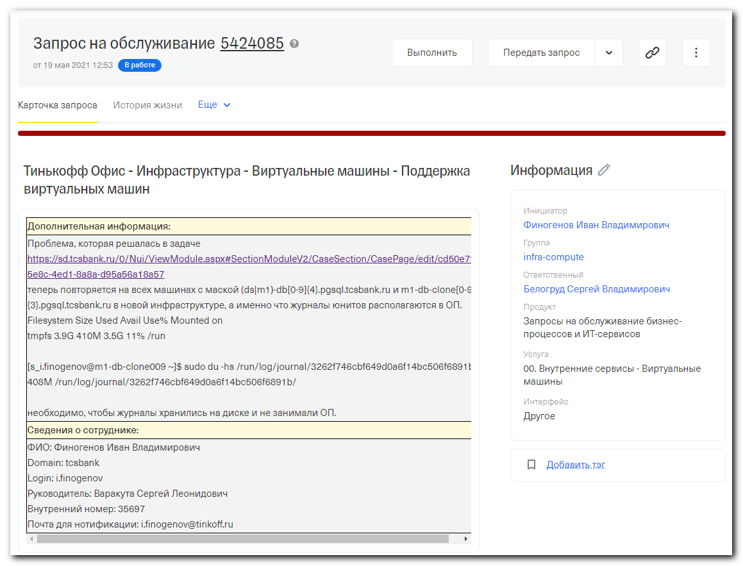

#
# Old task (2019), that URL was mentioned in body of the current task.
#
https://forge.tcsbank.ru/case/3409605/info
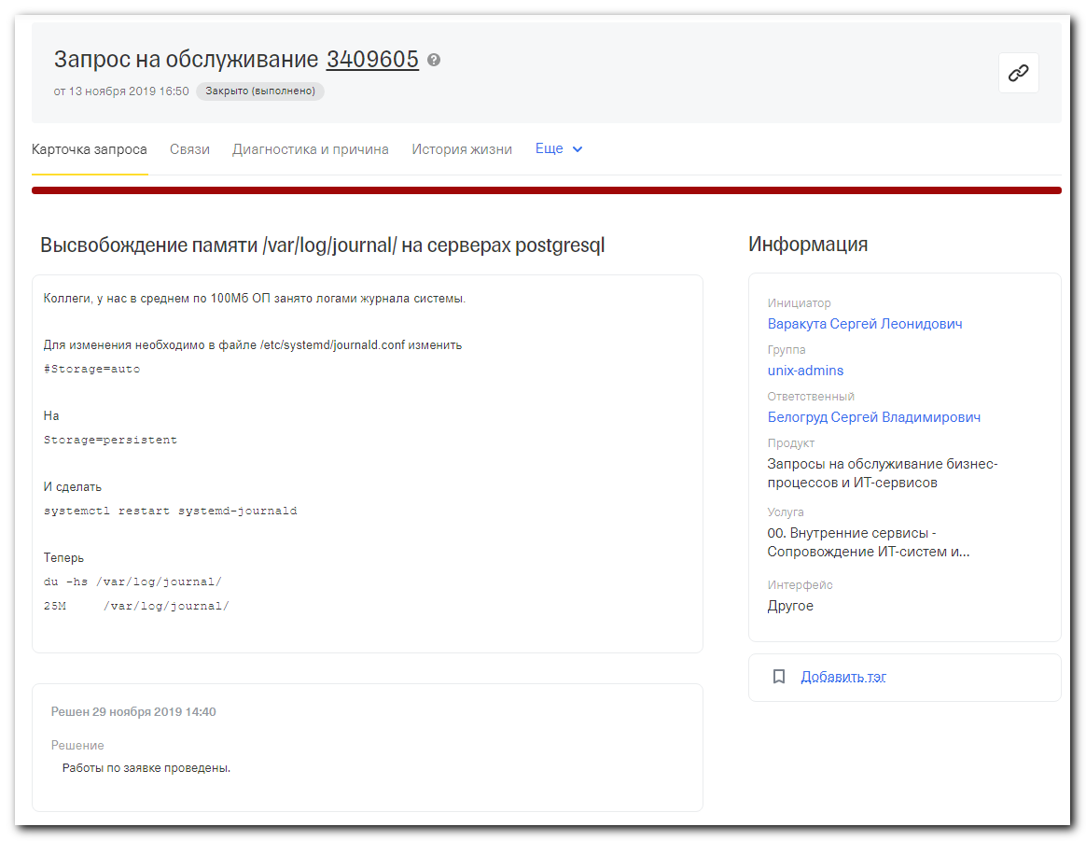

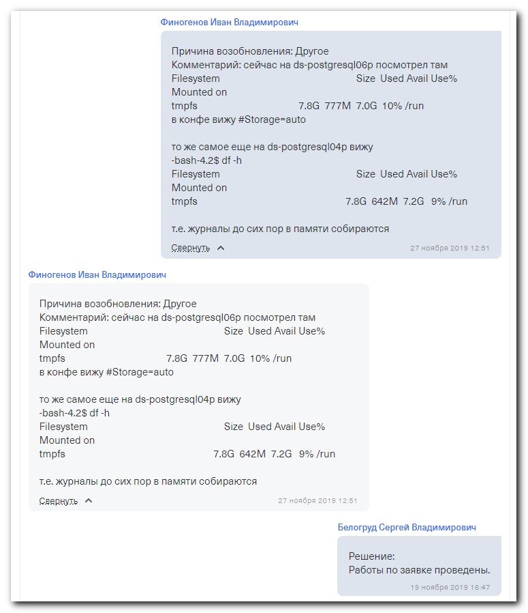
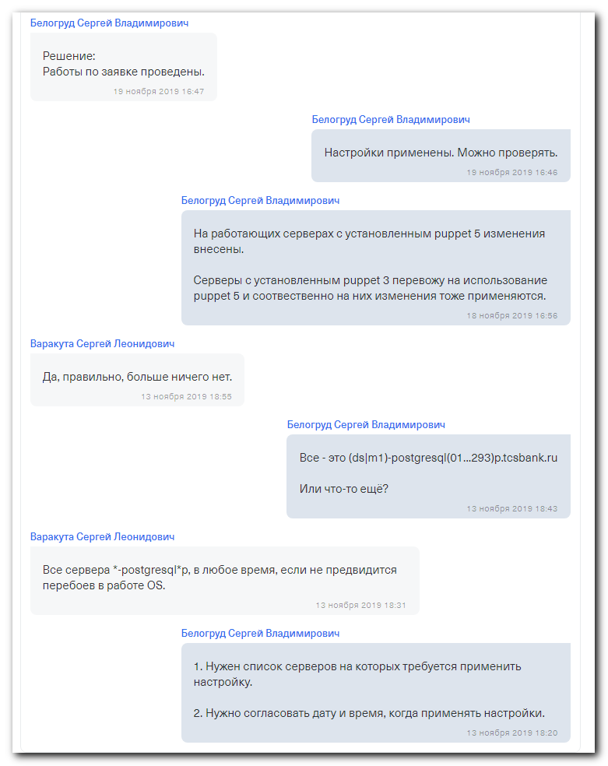

#
# I made my notes about previous task in follow documents:
"systemctl,journalctl",
"20191119 Puppet 5 - create new manifest and apply it on postgresql servers".

# I found Jira task (07.07.2020), from Varakuta Sergey about memory consumption for rsyslog and systemd on postgresql servers:
"на сервере ds-postgresql416p процессы rsyslog и systemd потребляют много памяти" (https://jira.tcsbank.ru/browse/IN-324) [Варакута Сергей]
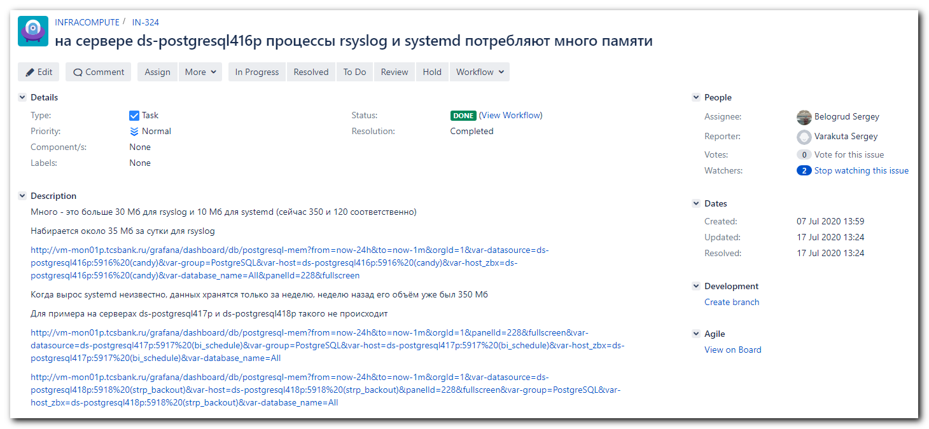
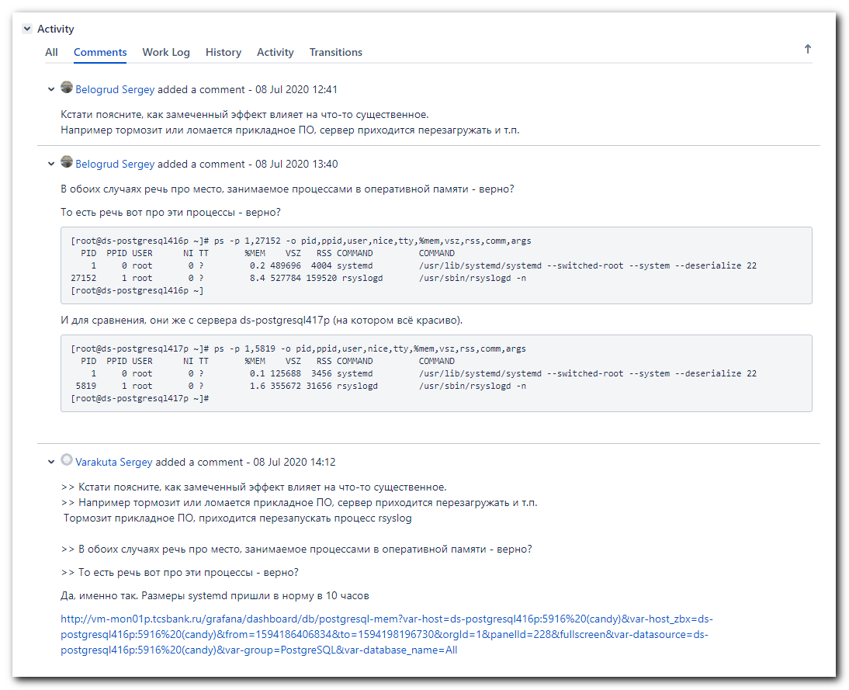
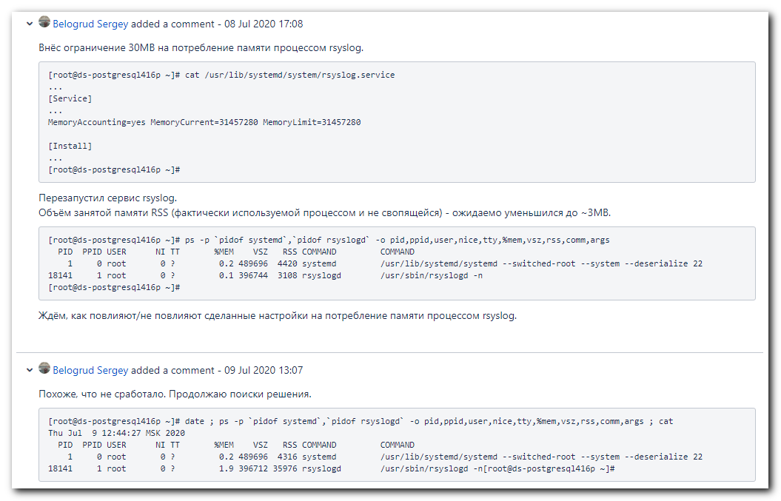
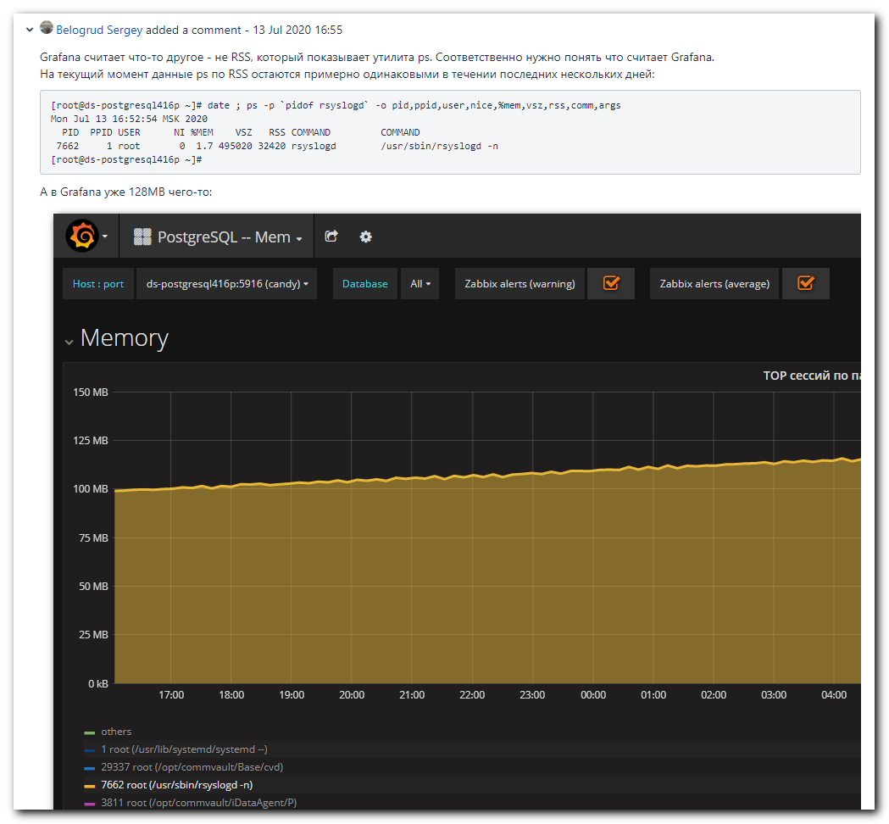
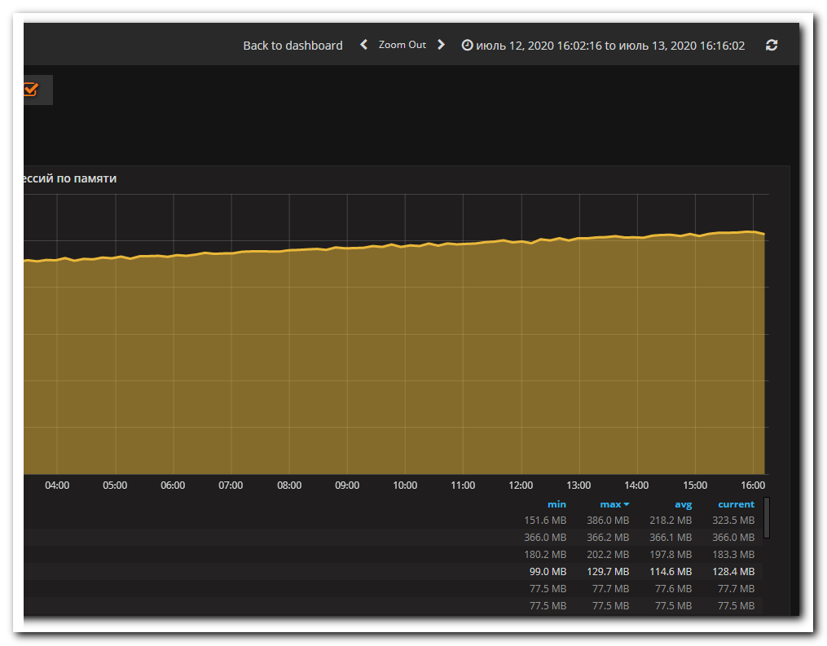
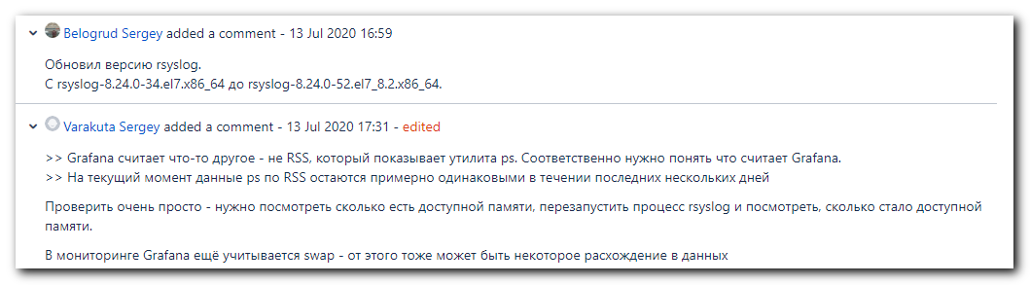
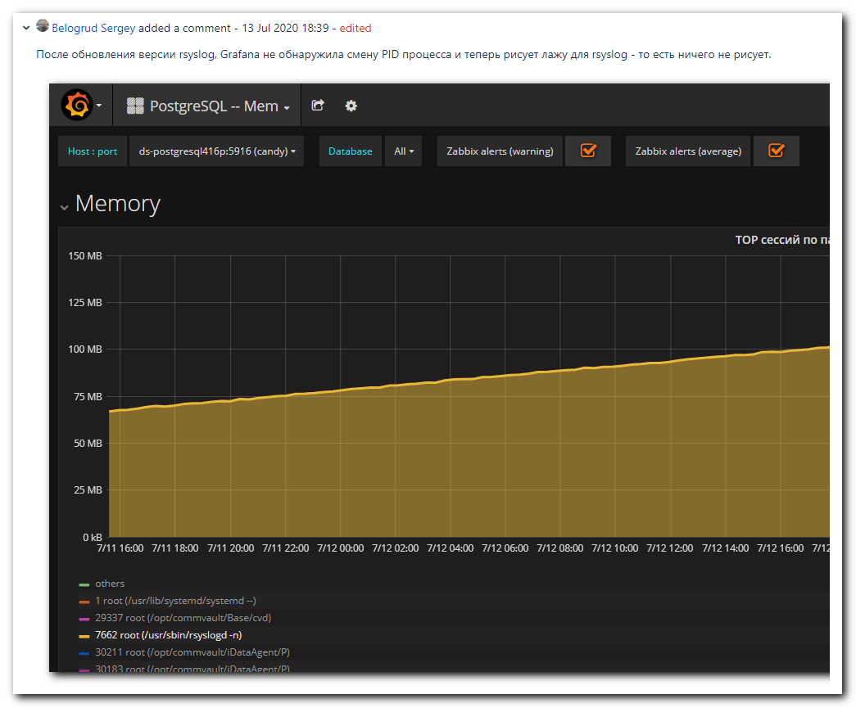
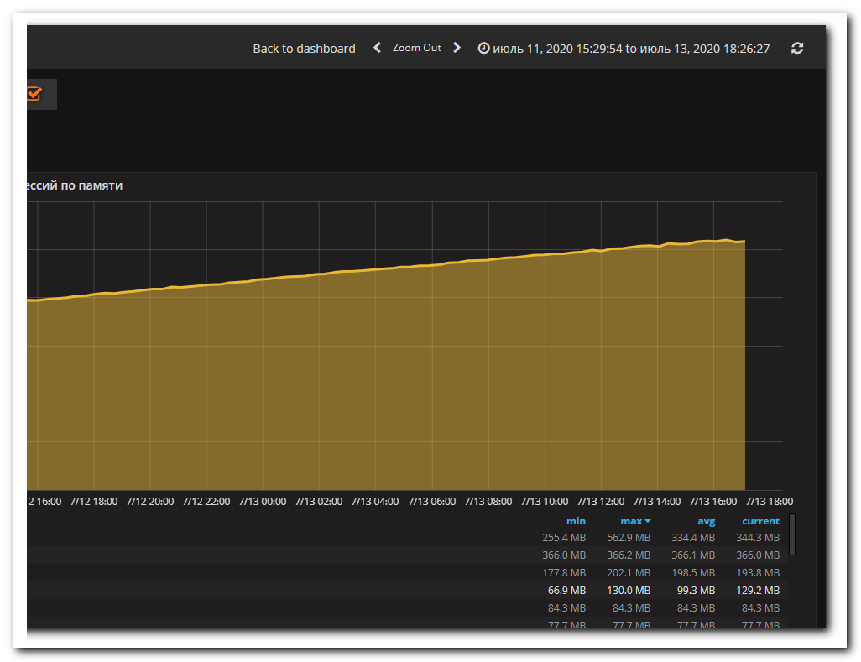
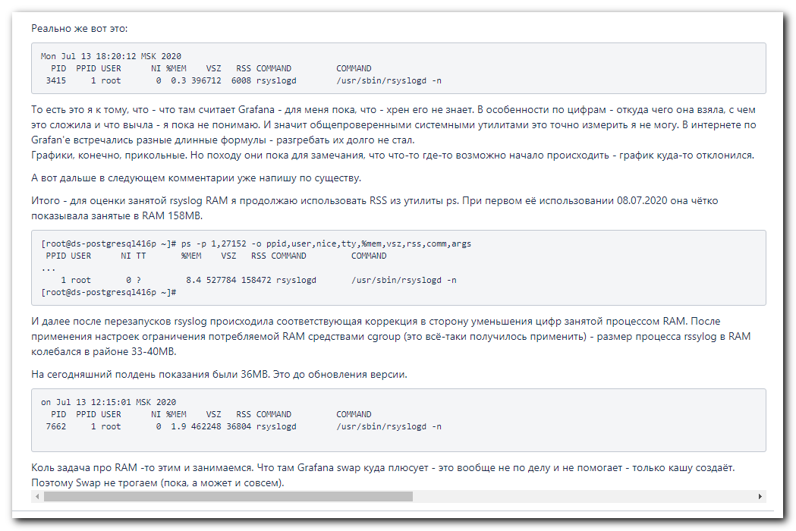
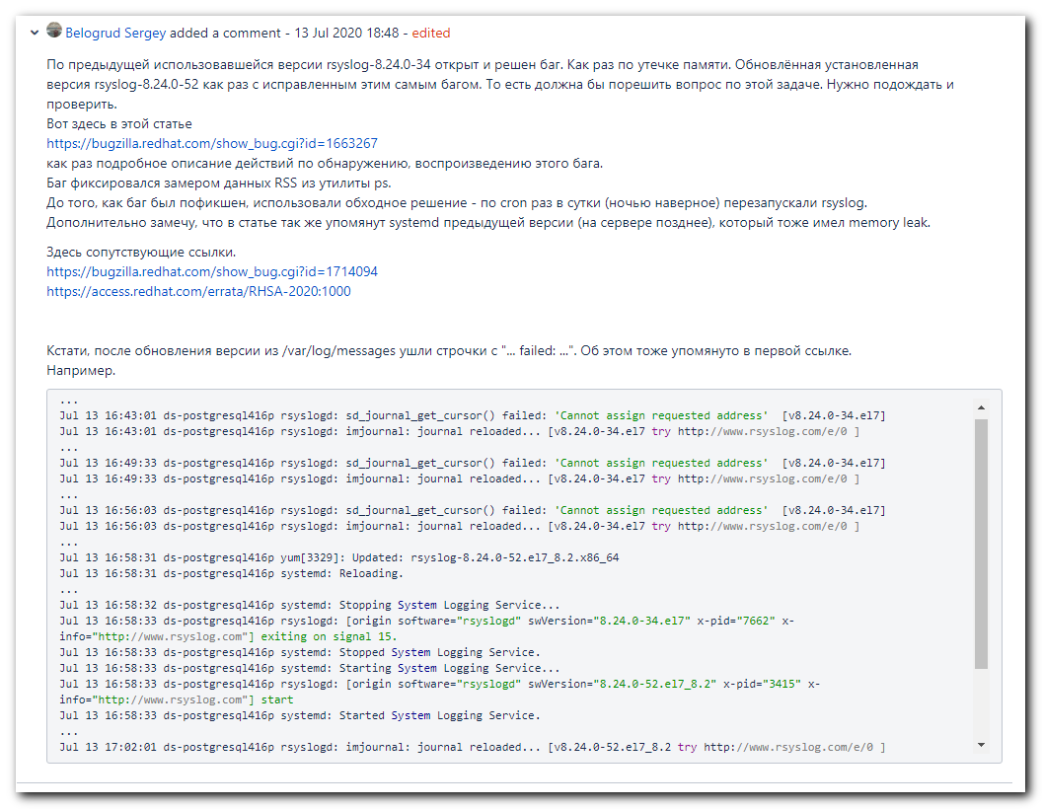
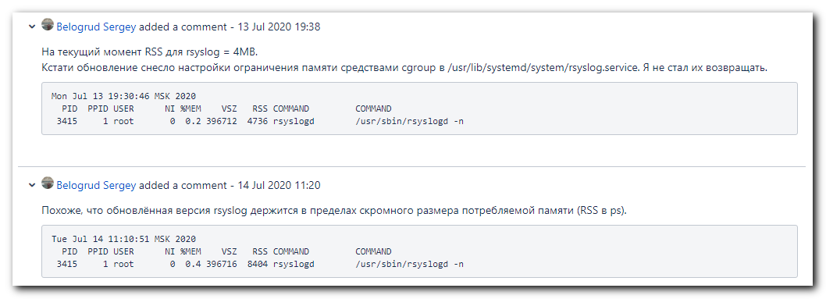
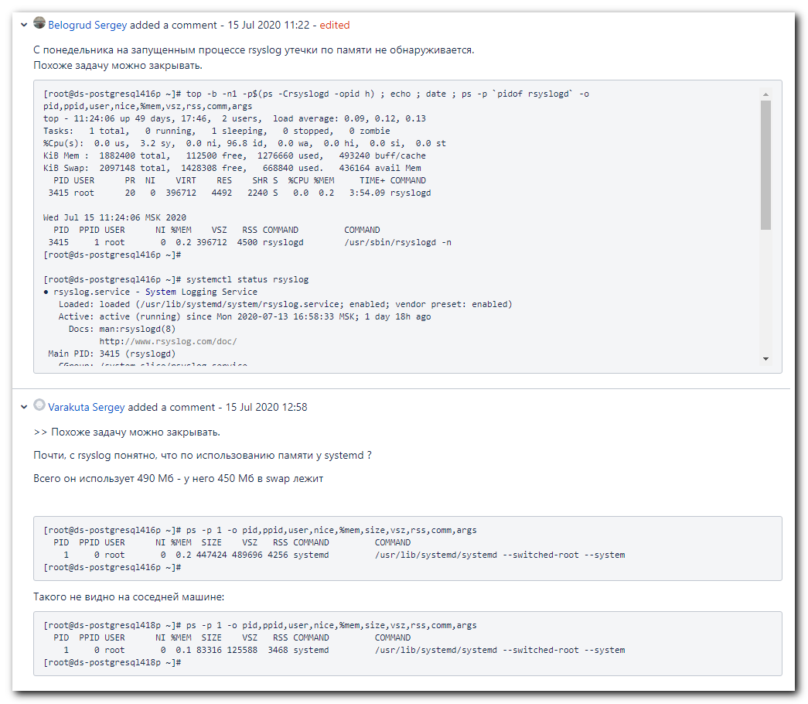
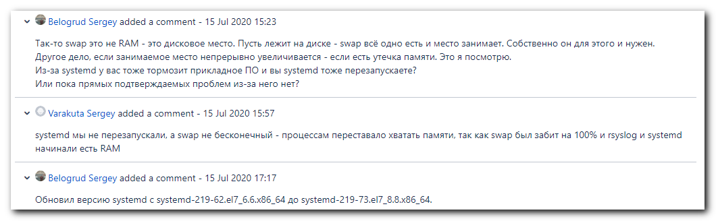
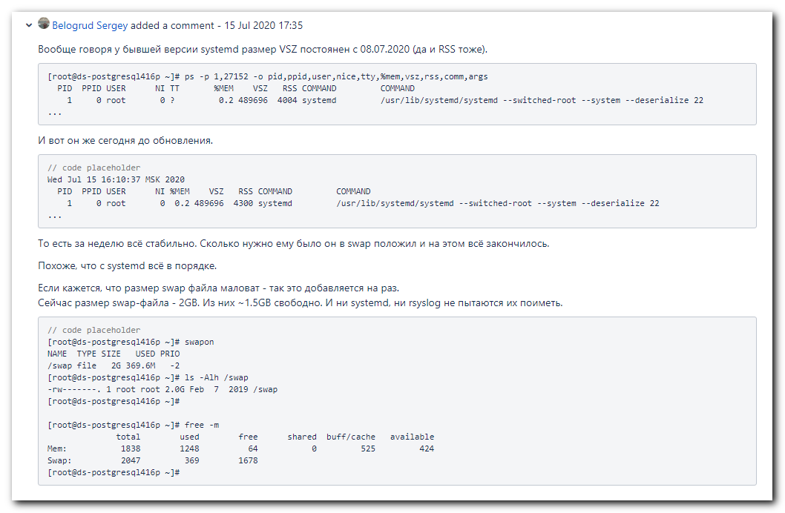
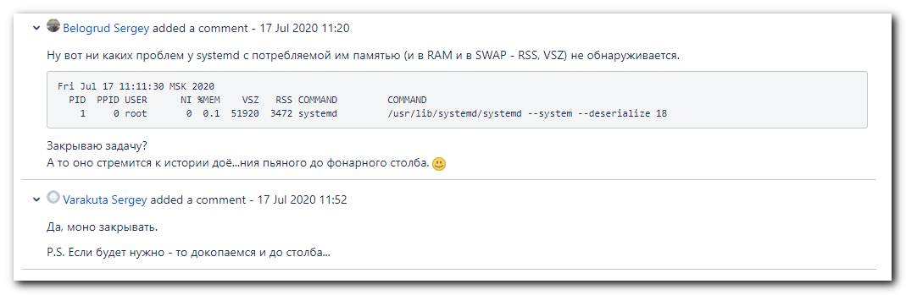

# 20210603
# On some servers I seen follow section during ansible ping ran.
#
ds-db0050.pgsql.tcsbank.ru | UNREACHABLE! => {
"changed": false,
"msg": "Invalid/incorrect password: Warning: Permanently added 'ds-db0050.pgsql.tcsbank.ru,10.224.8.21' (ECDSA) to the list of known hosts.\r\nPermission denied, please try again.",
"unreachable": true
}

#
# It was because on this server was not created user unix-ansible.
#
[s.belogrud@nb2339]# ssh s_s.belogrud@ds-db0050.pgsql.tcsbank.ru
Warning: Permanently added 'ds-db0050.pgsql.tcsbank.ru' (RSA) to the list of known hosts.
Creating home directory for s_s.belogrud.
[s_s.belogrud@ds-db0050 ~]$ sudo -i

We trust you have received the usual lecture from the local System
Administrator. It usually boils down to these three things:

#1) Respect the privacy of others.
#2) Think before you type.
#3) With great power comes great responsibility.

[sudo] password for s_s.belogrud:
[root@ds-db0050 ~]# id unix-ansible
id: unix-ansible: no such user
[root@ds-db0050 ~]# ls -Alh /home/
total 0
drwx------. 4 gitlab-ci-pgsql gitlab-ci-pgsql 90 Dec 4 16:33 gitlab-ci-pgsql
drwx--x--x. 10 root root 163 Jun 3 18:10 idm
drwx------. 2 pgbouncer pgbouncer 76 Dec 4 20:16 pgbouncer
drwx------. 3 svc_pg_dba svc_pg_dba 92 Feb 27 01:06 svc_pg_dba
[root@ds-db0050 ~]#

[root@ds-postgresql06p ~]# egrep -v "^#|^$" /etc/systemd/journald.conf
[Journal]
Storage = persistent
Compress = yes
Seal = yes
SplitMode = uid
SyncIntervalSec = 5m
RateLimitInterval = 30s
RateLimitBurst = 10000
SystemMaxUse = 100M
MaxFileSec = 1month
ForwardToSyslog = yes
ForwardToKMsg = no
ForwardToConsole = no
TTYPath = /dev/console
MaxLevelStore = debug
MaxLevelSyslog = debug
MaxLevelKMsg = notice
MaxLevelConsole = info
[root@ds-postgresql06p ~]#

[root@ds-postgresql06p ~]# systemctl status systemd-journald
● systemd-journald.service - Journal Service
Loaded: loaded (/usr/lib/systemd/system/systemd-journald.service; static; vendor preset: disabled)
Active: active (running) since Sat 2020-05-09 20:17:09 MSK; 1 years 0 months ago
Docs: man:systemd-journald.service(8)
man:journald.conf(5)
Main PID: 510 (systemd-journal)
Status: "Processing requests..."
CGroup: /system.slice/systemd-journald.service
└─510 /usr/lib/systemd/systemd-journald

Warning: Journal has been rotated since unit was started. Log output is incomplete or unavailable.
[root@ds-postgresql06p ~]#

[s.belogrud@nb2339]# ssh s_s.belogrud@ds-postgresql416p
Creating directory '/home/idm/s_s.belogrud'.
[s_s.belogrud@ds-postgresql416p ~]$ sudo -i

We trust you have received the usual lecture from the local System
Administrator. It usually boils down to these three things:

#1) Respect the privacy of others.
#2) Think before you type.
#3) With great power comes great responsibility.

[sudo] password for s_s.belogrud:
[root@ds-postgresql416p ~]# egrep -v "^#|^$" /etc/systemd/journald.conf
[Journal]
Storage = persistent
Compress = yes
Seal = yes
SplitMode = uid
SyncIntervalSec = 5m
RateLimitInterval = 30s
RateLimitBurst = 10000
SystemMaxUse = 100M
MaxFileSec = 1month
ForwardToSyslog = yes
ForwardToKMsg = no
ForwardToConsole = no
TTYPath = /dev/console
MaxLevelStore = debug
MaxLevelSyslog = debug
MaxLevelKMsg = notice
MaxLevelConsole = info
[root@ds-postgresql416p ~]#

# I found only these changes in parameters in the file /etc/systemd/journald.conf.
[Journal]
#Storage=auto
Storage = persistent
...
#RateLimitBurst=1000
RateLimitBurst = 10000
#SystemMaxUse=
SystemMaxUse = 100M
...

[root@ds-postgresql416p ~]# cat /etc/redhat-release
CentOS Linux release 7.6.1810 (Core)
[root@ds-postgresql416p ~]#

[root@ds-postgresql416p ~]# uptime
13:44:01 up 373 days, 20:06, 1 user, load average: 0.80, 0.78, 0.98
[root@ds-postgresql416p ~]#

[root@ds-postgresql416p ~]# rpm -q systemd
systemd-219-73.el7_8.8.x86_64
[root@ds-postgresql416p ~]#

[root@ds-postgresql416p ~]# free -m
total used free shared buff/cache available
Mem: 1838 1085 150 0 602 582
Swap: 2047 590 1457
[root@ds-postgresql416p ~]#

[root@ds-postgresql416p ~]# date ; ps -p `pidof systemd`,`pidof rsyslogd` -o pid,ppid,user,nice,tty,%mem,vsz,rss,comm,args
Fri Jun 4 13:49:31 MSK 2021
PID PPID USER NI TT %MEM VSZ RSS COMMAND COMMAND
1 0 root 0 ? 0.1 51924 2824 systemd /usr/lib/systemd/systemd --system --deserialize 18
3415 1 root 0 ? 0.3 429480 7272 rsyslogd /usr/sbin/rsyslogd -n
[root@ds-postgresql416p ~]#

[root@ds-postgresql416p ~]# ps -p 1 -o pid,ppid,user,nice,%mem,size,vsz,rss,comm,args
PID PPID USER NI %MEM SIZE VSZ RSS COMMAND COMMAND
1 0 root 0 0.1 9640 51924 2876 systemd /usr/lib/systemd/systemd --system --deserialize 18
[root@ds-postgresql416p ~]#

[root@ds-postgresql416p ~]# top -b -n1 -p$(ps -Crsyslogd -opid h) ; echo ; date ; ps -p `pidof rsyslogd` -o pid,ppid,user,nice,%mem,vsz,rss,comm,args
top - 13:46:34 up 373 days, 20:08, 1 user, load average: 0.51, 0.70, 0.92
Tasks: 1 total, 0 running, 1 sleeping, 0 stopped, 0 zombie
%Cpu(s): 3.3 us, 10.0 sy, 0.0 ni, 86.7 id, 0.0 wa, 0.0 hi, 0.0 si, 0.0 st
KiB Mem : 1882400 total, 126184 free, 1130004 used, 626212 buff/cache
KiB Swap: 2097148 total, 1492396 free, 604752 used. 578000 avail Mem

PID USER PR NI VIRT RES SHR S %CPU %MEM TIME+ COMMAND
3415 root 20 0 429480 8428 5820 S 0.0 0.4 936:48.21 rsyslogd

Fri Jun 4 13:46:34 MSK 2021
PID PPID USER NI %MEM VSZ RSS COMMAND COMMAND
3415 1 root 0 0.4 429480 8440 rsyslogd /usr/sbin/rsyslogd -n
[root@ds-postgresql416p ~]#

#
# How it was made in puppet.
#
[s.belogrud@nb2339]# cat /drives/c/Users/s.belogrud/Documents/MobaXterm/home/work/puppet/control/site/profile/manifests/postgres/journald.pp
class profile::postgres::journald {
class {'journald': options => {
'Storage' => 'persistent',
'SplitMode' => 'uid',
'ForwardToKMsg' => 'no',
'SystemMaxUse' => '100M',
}
}
}
[s.belogrud@nb2339]#

[s.belogrud@nb2339]# cat /drives/c/Users/s.belogrud/Documents/MobaXterm/home/work/puppet/control/.git/config
[core]
repositoryformatversion = 0
filemode = false
bare = false
logallrefupdates = true
ignorecase = true
[remote "origin"]
url = git@vm-gitlab01.tcsbank.ru:Puppet/control.git
fetch = +refs/heads/*:refs/remotes/origin/*
[branch "production"]
remote = origin
merge = refs/heads/production
[s.belogrud@nb2339]#

https://vm-gitlab01.tcsbank.ru/Puppet/control/blob/production/site/profile/manifests/postgres/journald.pp
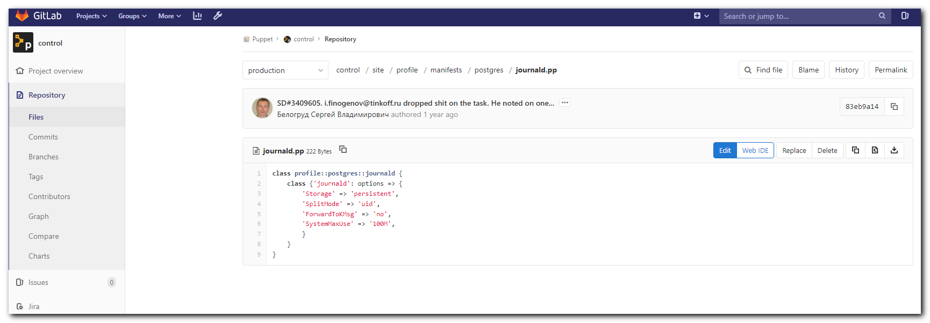

https://vm-gitlab01.tcsbank.ru/Puppet/control/commit/83eb9a14e8867037faff20cbfadf8a21f21ea489
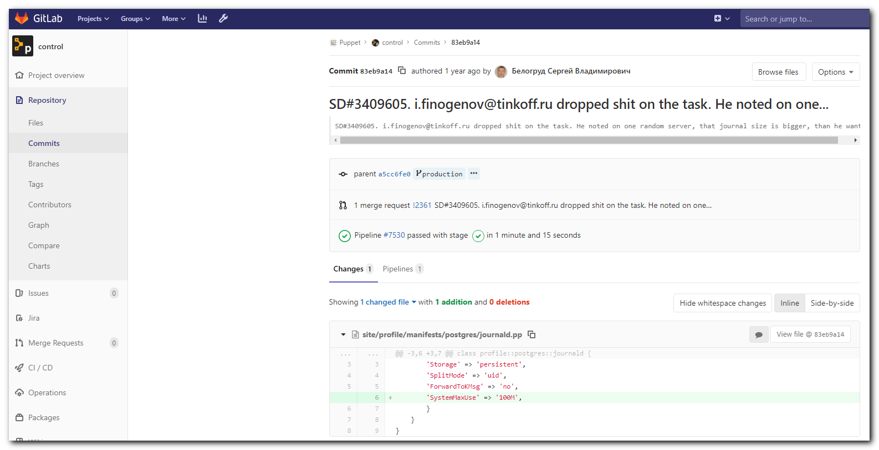

https://docs.ansible.com/ansible/latest/collections/community/general/ini_file_module.html
community.general.ini_file – Tweak settings in INI files
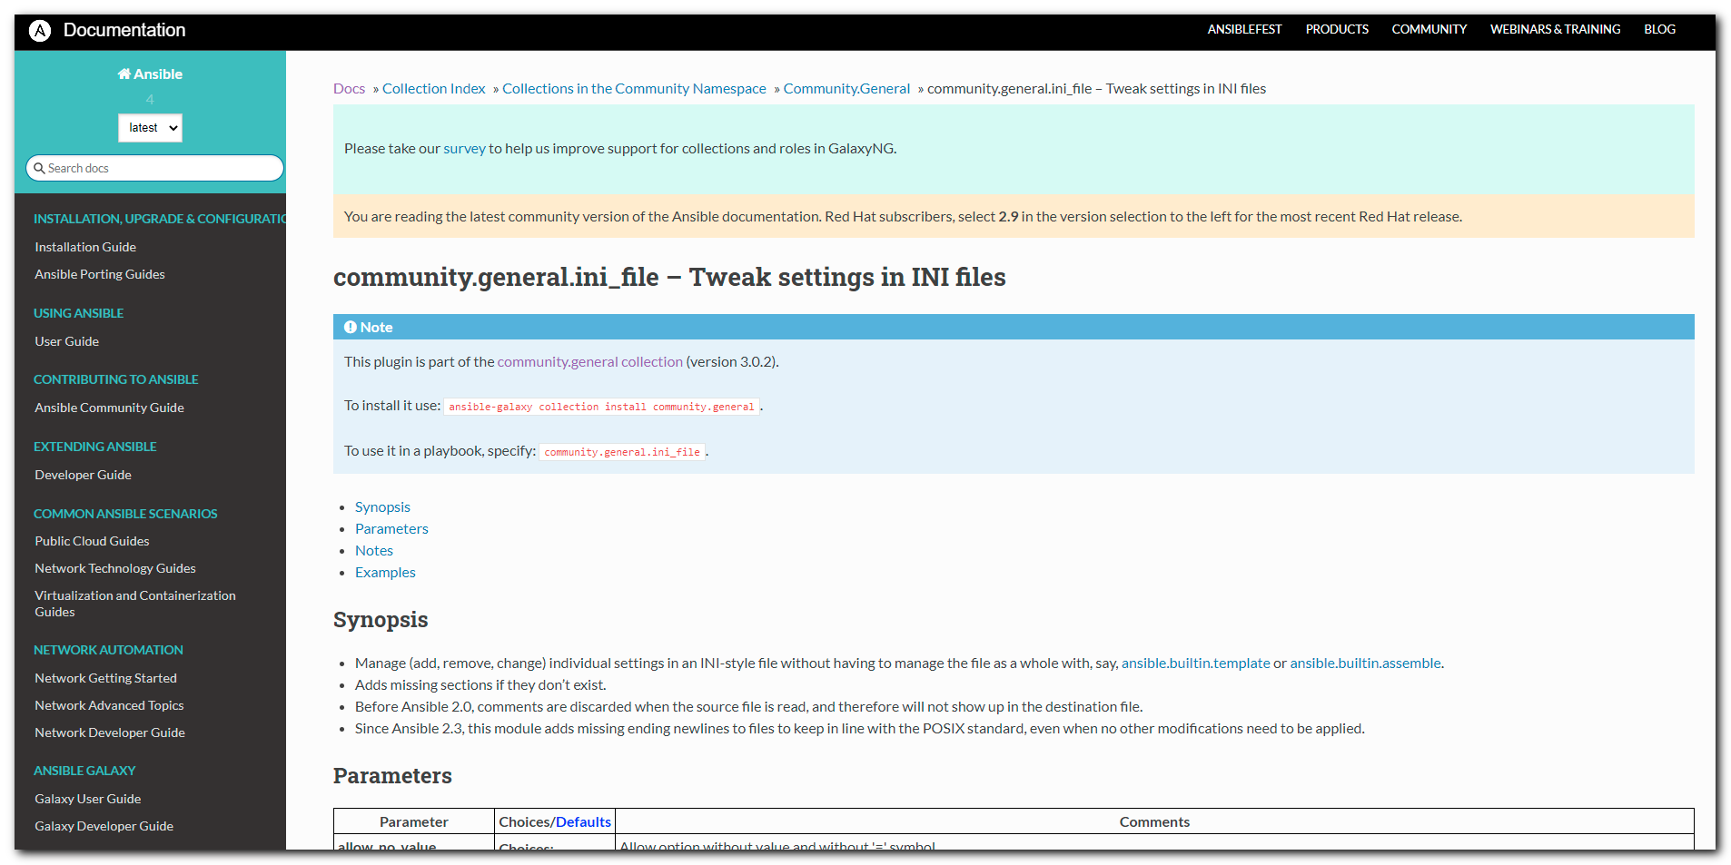

https://galaxy.ansible.com/community/general
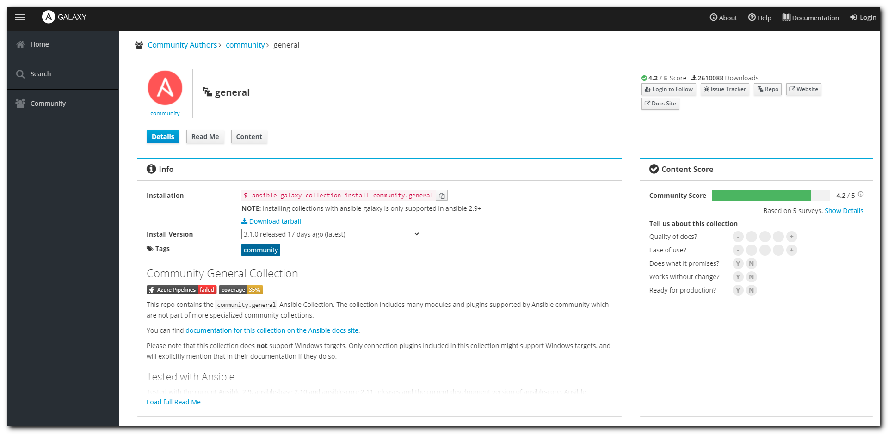

https://galaxy.ansible.com/download/community-general-3.1.0.tar.gz

https://docs.ansible.com/ansible/latest/user_guide/collections_using.html
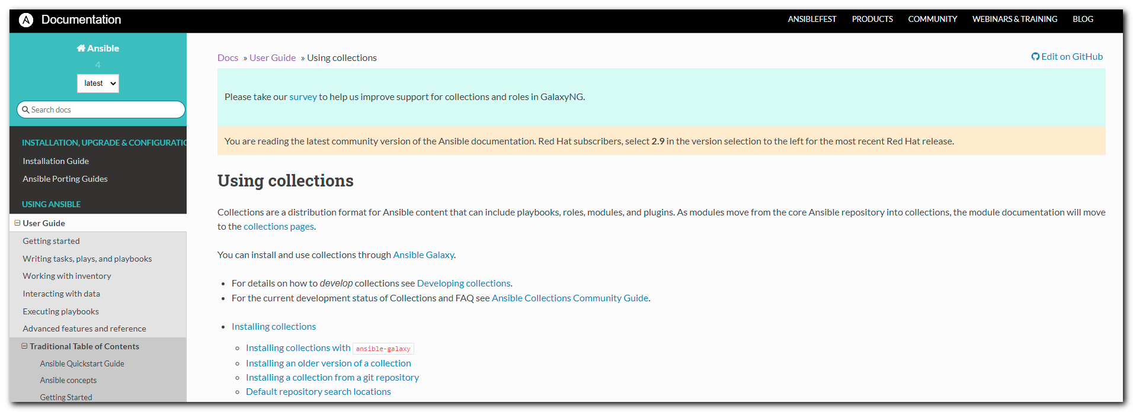

https://gist.github.com/wabouhamad/e0c2cb8937ecbf15870b34f3d669a8f3
OCP 3.6 Ansible playbook to tune journald

[root@m1-nexus01p ~]# cat /etc/systemd/journald.conf
# This file is part of systemd.
#
# systemd is free software; you can redistribute it and/or modify it
# under the terms of the GNU Lesser General Public License as published by
# the Free Software Foundation; either version 2.1 of the License, or
# (at your option) any later version.
#
# Entries in this file show the compile time defaults.
# You can change settings by editing this file.
# Defaults can be restored by simply deleting this file.
#
# See journald.conf(5) for details.

[Journal]
#Storage=auto
#Compress=yes
#Seal=yes
#SplitMode=uid
#SyncIntervalSec=5m
#RateLimitInterval=30s
#RateLimitBurst=1000
#SystemMaxUse=
#SystemKeepFree=
#SystemMaxFileSize=
#RuntimeMaxUse=
#RuntimeKeepFree=
#RuntimeMaxFileSize=
#MaxRetentionSec=
#MaxFileSec=1month
#ForwardToSyslog=yes
#ForwardToKMsg=no
#ForwardToConsole=no
#ForwardToWall=yes
#TTYPath=/dev/console
#MaxLevelStore=debug
#MaxLevelSyslog=debug
#MaxLevelKMsg=notice
#MaxLevelConsole=info
#MaxLevelWall=emerg
#LineMax=48K
[root@m1-nexus01p ~]#
[root@m1-nexus01p ~]# mkdir -p ~/work/20210604-1903/backup/
[root@m1-nexus01p ~]# cp /etc/systemd/journald.conf ~/work/20210604-1903/backup/
[root@m1-nexus01p ~]# ls -Alh /etc/systemd/journald.conf
-rw-r--r--. 1 root root 983 Feb 14 2019 /etc/systemd/journald.conf
[root@m1-nexus01p ~]#

root@nb2339:~# ansible-galaxy collection install community.general
Process install dependency map
Starting collection install process
Installing 'community.general:3.1.0' to '/root/.ansible/collections/ansible_collections/community/general'
root@nb2339:~#

root@nb2339:~# ls -Alh /root/.ansible/collections/ansible_collections/community/general/
total 1.5M
drwxr-xr-x 1 root root 512 Jun 4 19:33 .azure-pipelines
drwxr-xr-x 1 root root 512 Jun 4 19:33 .github
-rw------- 1 root root 6.6K Jun 4 19:33 .gitignore
-rw------- 1 root root 78K Jun 4 19:33 CHANGELOG.rst
-rw------- 1 root root 35K Jun 4 19:33 COPYING
-rw------- 1 root root 679K Jun 4 19:33 FILES.json
-rw------- 1 root root 844 Jun 4 19:33 MANIFEST.json
-rw------- 1 root root 5.2K Jun 4 19:33 README.md
drwxr-xr-x 1 root root 512 Jun 4 19:33 changelogs
-rw------- 1 root root 5.9K Jun 4 19:33 commit-rights.md
drwxr-xr-x 1 root root 512 Jun 4 19:33 meta
drwxr-xr-x 1 root root 512 Jun 4 19:33 plugins
drwxr-xr-x 1 root root 512 Jun 4 19:33 scripts
drwxr-xr-x 1 root root 512 Jun 4 19:33 tests
root@nb2339:~#

#
# Examples of using ansible-galaxy.

20210325 Переустановка ОС на сервере ds-ch-prod06 - RedHat 7.6

[support@nb2339]# ansible-galaxy install -r roles/ans_int/freeipa-client/requirements.yml -p roles/ans_int/
- extracting ansible-role-chrony to /mnt/c/data/work/ansible/stash.tcsbank.ru/roles/ans_int/ansible-role-chrony
- ansible-role-chrony (v1.0.0) was installed successfully
[support@nb2339]#

Копия 20200324 Usage msp-mcp - Ansible playbooks and roles made by Mogilevsky Kirill.docx
(env) [support@centos msp-scm]$ ansible-galaxy install -r requirements.yml --force
- changing role dco.common.nfs from master to master
- extracting dco.common.nfs to /home/support/work/20190605-1120.msp-scm/msp-scm/roles/dco.common.nfs
- dco.common.nfs (master) was installed successfully
- changing role dco.common.repo from master to master
- extracting dco.common.repo to /home/support/work/20190605-1120.msp-scm/msp-scm/roles/dco.common.repo
- dco.common.repo (master) was installed successfully

[support@nb2339]# cat roles/unix/pgsql_journald/requirements.yml
---
collections:
- name: community.general
...
[support@nb2339]#

[support@nb2339]# cd roles/unix/pgsql_journald/
[support@nb2339]# ansible-galaxy collection install -r requirements.yml
Process install dependency map
Starting collection install process
Installing 'community.general:3.1.0' to '/home/support/.ansible/collections/ansible_collections/community/general'
[support@nb2339]# cd -
/mnt/c/data/work/ansible/stash.tcsbank.ru
[support@nb2339]#

[support@nb2339]# ls /home/support/.ansible/collections/ansible_collections/community/general/plugins/*/ini*
/home/support/.ansible/collections/ansible_collections/community/general/plugins/modules/ini_file.py
[support@nb2339]#

[support@nb2339]# ansible --version
ansible 2.9.6
config file = /mnt/c/data/work/ansible/stash.tcsbank.ru/ansible.cfg
configured module search path = ['/home/support/.ansible/plugins/modules', '/usr/share/ansible/plugins/modules']
ansible python module location = /usr/lib/python3/dist-packages/ansible
executable location = /usr/bin/ansible
python version = 3.8.5 (default, Jan 27 2021, 15:41:15) [GCC 9.3.0]
[support@nb2339]#

[support@nb2339]# export ANSIBLE_CONFIG=ansible.cfg ; logfile="$(date +%Y%m%d-%H%M).playbook.log.txt" ; ansible-playbook 20210604-1840.pgsql_jounald.yml -i list_of_hosts --become --extra-vars "ansible_user=unix-ansible ansible_password=$(pass common/linux-unix-ansible) ansible_sudo_pass=$(pass common/linux-unix-ansible) ansible_ssh_common_args='-oStrictHostKeyChecking=no -oPubkeyAuthentication=no -oUserKnownHostsFile=/dev/null'" --check --diff | tee -a ./output/${logfile}
ERROR! couldn't resolve module/action 'community:general:ini_file'. This often indicates a misspelling, missing collection, or incorrect module path.

The error appears to be in '/mnt/c/data/work/ansible/stash.tcsbank.ru/roles/unix/pgsql_journald/tasks/main.yml': line 2, column 3, but may
be elsewhere in the file depending on the exact syntax problem.

The offending line appears to be:

---
- name: Enable journald option 'Storage - persistence'.
^ here
[support@nb2339]#

[support@nb2339]# ansible-galaxy collection list
usage: ansible-galaxy collection [-h] COLLECTION_ACTION ...
ansible-galaxy collection: error: argument COLLECTION_ACTION: invalid choice: 'list' (choose from 'init', 'build', 'publish', 'install')
[support@nb2339]#

[support@nb2339]# export COLLECTIONS_PATH=/home/support/.ansible/collections
[support@nb2339]# echo $COLLECTIONS_PATH
/home/support/.ansible/collections
[support@nb2339]#

[support@nb2339]# cd roles/unix/pgsql_journald/
[support@nb2339]# ll
total 5
drwxrwxrwx 1 support support 512 Jun 4 19:48 ./
drwxrwxrwx 1 support support 512 Jun 3 16:02 ../
drwxrwxrwx 1 support support 512 Jun 3 16:59 .git/
-rwxrwxrwx 1 support support 539 Jun 3 16:48 .travis.yml*
-rwxrwxrwx 1 support support 1328 Jun 3 16:48 README.md*
drwxrwxrwx 1 support support 512 Jun 3 16:48 defaults/
drwxrwxrwx 1 support support 512 Jun 3 16:48 files/
drwxrwxrwx 1 support support 512 Jun 3 16:48 handlers/
drwxrwxrwx 1 support support 512 Jun 3 16:48 meta/
-rwxrwxrwx 1 support support 49 Jun 4 19:48 requirements.yml*
drwxrwxrwx 1 support support 512 Jun 4 20:07 tasks/
drwxrwxrwx 1 support support 512 Jun 3 16:48 templates/
drwxrwxrwx 1 support support 512 Jun 3 16:48 tests/
drwxrwxrwx 1 support support 512 Jun 3 16:48 vars/
[support@nb2339]# ansible-galaxy collection install -r requirements.yml -p ./collections
[WARNING]: The specified collections path '/mnt/c/data/work/ansible/stash.tcsbank.ru/roles/unix/pgsql_journald/collections' is not part of the configured Ansible
collections paths '/home/support/.ansible/collections:/usr/share/ansible/collections'. The installed collection won't be picked up in an Ansible run.
Process install dependency map
Starting collection install process
Installing 'community.general:3.1.0' to '/mnt/c/data/work/ansible/stash.tcsbank.ru/roles/unix/pgsql_journald/collections/ansible_collections/community/general'
[support@nb2339]#
[support@nb2339]# cd -
/mnt/c/data/work/ansible/stash.tcsbank.ru
[support@nb2339]#

[support@nb2339]# export ANSIBLE_CONFIG=ansible.cfg ; logfile="$(date +%Y%m%d-%H%M).playbook.log.txt" ; ansible-playbook 20210604-1840.pgsql_jounald.yml -i list_of_hosts --become --extra-vars "ansible_user=unix-ansible ansible_password=$(pass common/linux-unix-ansible) ansible_sudo_pass=$(pass common/linux-unix-ansible) ansible_ssh_common_args='-oStrictHostKeyChecking=no -oPubkeyAuthentication=no -oUserKnownHostsFile=/dev/null'" --check --diff | tee -a ./output/${logfile}

PLAY [pgsql_journald] ********************************************************************************************************************************************
TASK [Gathering Facts] *******************************************************************************************************************************************Friday 04 June 2021 20:30:50 +0300 (0:00:00.595) 0:00:00.595 ***********
ok: [m1-nexus01p]

TASK [unix/pgsql_journald : Enable journald option 'Storage - persistence'.] *************************************************************************************Friday 04 June 2021 20:30:56 +0300 (0:00:05.774) 0:00:06.370 ***********
--- before: /etc/systemd/journald.conf (content)
+++ after: /etc/systemd/journald.conf (content)
@@ -12,7 +12,7 @@
# See journald.conf(5) for details.

[Journal]
-#Storage=auto
+Storage=persistent
#Compress=yes
#Seal=yes
#SplitMode=uid

changed: [m1-nexus01p]

PLAY RECAP *******************************************************************************************************************************************************m1-nexus01p : ok=2 changed=1 unreachable=0 failed=0 skipped=0 rescued=0 ignored=0

Friday 04 June 2021 20:30:58 +0300 (0:00:01.736) 0:00:08.107 ***********
===============================================================================
Gathering Facts ------------------------------------------------------------------------------------------------------------------------------------------- 5.77s
unix/pgsql_journald : Enable journald option 'Storage - persistence'. ------------------------------------------------------------------------------------- 1.74s
[support@nb2339]#

#
# It still working without path definition.
#
[support@nb2339]# export COLLECTIONS_PATH=
[support@nb2339]# echo $COLLECTIONS_PATH

[support@nb2339]# export ANSIBLE_CONFIG=ansible.cfg ; logfile="$(date +%Y%m%d-%H%M).playbook.log.txt" ; ansible-playbook 20210604-1840.pgsql_jounald.yml -i list_of_hosts --become --extra-vars "ansible_user=unix-ansible ansible_password=$(pass common/linux-unix-ansible) ansible_sudo_pass=$(pass common/linux-unix-ansible) ansible_ssh_common_args='-oStrictHostKeyChecking=no -oPubkeyAuthentication=no -oUserKnownHostsFile=/dev/null'" --check --diff | tee -a ./output/${logfile}

PLAY [pgsql_journald] ********************************************************************************************************************************************
TASK [Gathering Facts] *******************************************************************************************************************************************Friday 04 June 2021 20:36:44 +0300 (0:00:00.325) 0:00:00.325 ***********
ok: [m1-nexus01p]

TASK [unix/pgsql_journald : Enable journald option 'Storage - persistence'.] *************************************************************************************Friday 04 June 2021 20:36:48 +0300 (0:00:04.185) 0:00:04.511 ***********
--- before: /etc/systemd/journald.conf (content)
+++ after: /etc/systemd/journald.conf (content)
@@ -12,7 +12,7 @@
# See journald.conf(5) for details.

[Journal]
-#Storage=auto
+Storage=persistent
#Compress=yes
#Seal=yes
#SplitMode=uid

changed: [m1-nexus01p]

PLAY RECAP *******************************************************************************************************************************************************m1-nexus01p : ok=2 changed=1 unreachable=0 failed=0 skipped=0 rescued=0 ignored=0

Friday 04 June 2021 20:36:50 +0300 (0:00:01.823) 0:00:06.334 ***********
===============================================================================
Gathering Facts ------------------------------------------------------------------------------------------------------------------------------------------- 4.19s
unix/pgsql_journald : Enable journald option 'Storage - persistence'. ------------------------------------------------------------------------------------- 1.82s
[support@nb2339]#

[s.belogrud@nb2339]# vim .gitignore
[s.belogrud@nb2339]# git status
На ветке development
нечего коммитить, нет изменений в рабочем каталоге
[s.belogrud@nb2339]# cat .gitignore
.gitignore
collections/
[s.belogrud@nb2339]#

# 20210607
# https://qna.habr.com/q/36189
# Recomendations to clean journals.
journalctl --vacuum-size=128M
journalctl --vacuum-time=1d
systemctl restart systemd-journald.service
systemctl start systemd-journal-flush
#
# On CentOS 7.8.
# Default journald.conf config.
#
[root@ds-db0050 ~]# cat /etc/redhat-release
CentOS Linux release 7.8.2003 (Core)
[root@ds-db0050 ~]#

[root@ds-db0050 ~]# cat /etc/systemd/journald.conf
...
[Journal]
#Storage=auto
#Compress=yes
#Seal=yes
#SplitMode=uid
#SyncIntervalSec=5m
#RateLimitInterval=30s
#RateLimitBurst=1000
#SystemMaxUse=
#SystemKeepFree=
#SystemMaxFileSize=
#RuntimeMaxUse=
#RuntimeKeepFree=
#RuntimeMaxFileSize=
#MaxRetentionSec=
#MaxFileSec=1month
#ForwardToSyslog=yes
#ForwardToKMsg=no
#ForwardToConsole=no
#ForwardToWall=yes
#TTYPath=/dev/console
#MaxLevelStore=debug
#MaxLevelSyslog=debug
#MaxLevelKMsg=notice
#MaxLevelConsole=info
#MaxLevelWall=emerg
#LineMax=48K
[root@ds-db0050 ~]#

[s.belogrud@nb2339]# ssh s_s.belogrud@ds-db0050.pgsql.tcsbank.ru
Last login: Thu Jun 3 18:10:20 2021 from 172.30.76.78
[s_s.belogrud@ds-db0050 ~]$ sudo -i
[sudo] password for s_s.belogrud:
[root@ds-db0050 ~]# du -sh /run/log/journal/*
96M /run/log/journal/3262f746cbf649d0a6f14bc506f6891b
[root@ds-db0050 ~]#
[root@ds-db0050 ~]# journalctl --disk-usage
Archived and active journals take up 96.0M on disk.
[root@ds-db0050 ~]#

[root@ds-db0050 ~]# date ; ps -p `pidof systemd`,`pidof rsyslogd` -o pid,ppid,user,nice,tty,%mem,vsz,rss,comm,args
Mon Jun 7 18:22:54 MSK 2021
PID PPID USER NI TT %MEM VSZ RSS COMMAND COMMAND
1 0 root 0 ? 0.2 54816 4720 systemd /usr/lib/systemd/systemd --switched-root --system --deserialize 22
1145 1 root 0 ? 0.2 306536 4924 rsyslogd /usr/sbin/rsyslogd -n
[root@ds-db0050 ~]#

[root@ds-db0050 ~]# free -m
total used free shared buff/cache available
Mem: 1838 1013 65 96 759 602
Swap: 2047 64 1983
[root@ds-db0050 ~]#

#
# On Ubuntu 18.04.
# Default journald.conf config.
#
root@m1-nexus02p:~# grep "^VERSION=" /etc/os-release
VERSION="18.04.5 LTS (Bionic Beaver)"
root@m1-nexus02p:~#

root@m1-nexus02p:~# cat /etc/systemd/journald.conf
...
[Journal]
#Storage=auto
#Compress=yes
#Seal=yes
#SplitMode=uid
#SyncIntervalSec=5m
#RateLimitIntervalSec=30s
#RateLimitBurst=1000
#SystemMaxUse=
#SystemKeepFree=
#SystemMaxFileSize=
#SystemMaxFiles=100
#RuntimeMaxUse=
#RuntimeKeepFree=
#RuntimeMaxFileSize=
#RuntimeMaxFiles=100
#MaxRetentionSec=
#MaxFileSec=1month
#ForwardToSyslog=yes
#ForwardToKMsg=no
#ForwardToConsole=no
#ForwardToWall=yes
#TTYPath=/dev/console
#MaxLevelStore=debug
#MaxLevelSyslog=debug
#MaxLevelKMsg=notice
#MaxLevelConsole=info
#MaxLevelWall=emerg
#LineMax=48K
root@m1-nexus02p:~#

root@m1-nexus02p:~# journalctl --disk-usage
Journal file /var/log/journal/150a2947159e40918b719c2aab18253d/user-1000.journal is truncated, ignoring file.
Archived and active journals take up 1.4G in the file system.
root@m1-nexus02p:~# du -sh /var/log/journal/*
1.5G /var/log/journal/150a2947159e40918b719c2aab18253d
root@m1-nexus02p:~#

root@m1-nexus02p:~# date ; ps -p `pidof systemd`,`pidof rsyslogd` -o pid,ppid,user,nice,tty,%mem,vsz,rss,comm,args
Mon Jun 7 18:27:07 MSK 2021
PID PPID USER NI TT %MEM VSZ RSS COMMAND COMMAND
1118 1 syslog 0 ? 0.1 275292 4372 rsyslogd /usr/sbin/rsyslogd -n
11364 1 bsv 0 ? 0.1 76696 7460 systemd /lib/systemd/systemd --user
root@m1-nexus02p:~#

#
# On this system journald.conf configured.
#
[root@ds-postgresql416p ~]# cat /etc/redhat-release
CentOS Linux release 7.6.1810 (Core)
[root@ds-postgresql416p ~]#

[root@ds-postgresql416p ~]# journalctl --disk-usage
Archived and active journals take up 191.5M on disk.
[root@ds-postgresql416p ~]#

[root@ds-postgresql416p ~]# egrep -v "^#|^$" /etc/systemd/journald.conf
[Journal]
Storage = persistent
Compress = yes
Seal = yes
SplitMode = uid
SyncIntervalSec = 5m
RateLimitInterval = 30s
RateLimitBurst = 10000
SystemMaxUse = 100M
MaxFileSec = 1month
ForwardToSyslog = yes
ForwardToKMsg = no
ForwardToConsole = no
TTYPath = /dev/console
MaxLevelStore = debug
MaxLevelSyslog = debug
MaxLevelKMsg = notice
MaxLevelConsole = info
[root@ds-postgresql416p ~]#

#
# Creation user unix-ansible.
#
[support@nb2339]# logfile="$(date +%Y%m%d-%H%M).playbook.log.txt" ; ansible-playbook create_users_unix_ansible.yml -i list_of_hosts --become --extra-vars "ansible_user=s_s.belogrud ansible_password=$(pass common/linux-freeipa) ansible_sudo_pass=$(pass common/linux-freeipa) ansible_ssh_common_args='-oStrictHostKeyChecking=no -oPubkeyAuthentication=no -oUserKnownHostsFile=/dev/null'" | tee -a ./output/${logfile}

PLAY [create_users_unix_ansible] *********************************************************************************************************************************
TASK [Gathering Facts] *******************************************************************************************************************************************ok: [ds-db0050.pgsql.tcsbank.ru]

TASK [Create unix-ansible group] *********************************************************************************************************************************changed: [ds-db0050.pgsql.tcsbank.ru]

TASK [Create unix-ansible user] **********************************************************************************************************************************changed: [ds-db0050.pgsql.tcsbank.ru]

TASK [Add ssh key to unix-ansible user] **************************************************************************************************************************changed: [ds-db0050.pgsql.tcsbank.ru]

TASK [Adding user into sudo group if host OS is Ubuntu] **********************************************************************************************************skipping: [ds-db0050.pgsql.tcsbank.ru]

TASK [Adding user into wheel group if host OS is RedHat, Centos] *************************************************************************************************changed: [ds-db0050.pgsql.tcsbank.ru]

PLAY RECAP *******************************************************************************************************************************************************ds-db0050.pgsql.tcsbank.ru : ok=5 changed=4 unreachable=0 failed=0 skipped=1 rescued=0 ignored=0

[support@nb2339]#

#
# 202100608
#
[s.belogrud@nb2339]# ssh s_s.belogrud@ds-db0010.pgsql.tcsbank.ru
Warning: Permanently added 'ds-db0010.pgsql.tcsbank.ru' (RSA) to the list of known hosts.
Last login: Tue Jun 8 17:11:22 2021 from 172.30.65.47
[s_s.belogrud@ds-db0010 ~]$ sudo -i
[sudo] password for s_s.belogrud:
[root@ds-db0010 ~]#
[root@ds-db0010 ~]# cat /etc/redhat-release
CentOS Linux release 7.8.2003 (Core)
[root@ds-db0010 ~]#
[root@ds-db0010 ~]# rpm -q systemd
systemd-219-73.el7_8.9.x86_64
[root@ds-db0010 ~]#

[root@ds-db0010 ~]# free -m
total used free shared buff/cache available
Mem: 1838 1010 87 97 740 606
Swap: 2047 0 2047
[root@ds-db0010 ~]#

[root@ds-db0010 ~]# date ; ps -p `pidof systemd`,`pidof rsyslogd` -o pid,ppid,user,nice,tty,%mem,vsz,rss,comm,args
Tue Jun 8 17:33:45 MSK 2021
PID PPID USER NI TT %MEM VSZ RSS COMMAND COMMAND
1 0 root 0 ? 0.3 79844 7176 systemd /usr/lib/systemd/systemd --switched-root --system --deserialize 22
1155 1 root 0 ? 0.4 306536 8296 rsyslogd /usr/sbin/rsyslogd -n
[root@ds-db0010 ~]#

[root@ds-db0010 ~]# ps -p 1 -o pid,ppid,user,nice,%mem,size,vsz,rss,comm,args
PID PPID USER NI %MEM SIZE VSZ RSS COMMAND COMMAND
1 0 root 0 0.3 35636 79844 7200 systemd /usr/lib/systemd/systemd --switched-root --system --deserialize 22
[root@ds-db0010 ~]#

[root@ds-db0010 ~]# top -b -n1 -p$(ps -Csystemd -opid h) ; echo ; date ; ps -p `pidof systemd` -o pid,ppid,user,nice,%mem,vsz,rss,comm,args
top - 17:36:01 up 4 days, 2:47, 1 user, load average: 0.54, 0.33, 0.18
Tasks: 1 total, 0 running, 1 sleeping, 0 stopped, 0 zombie
%Cpu(s): 0.0 us, 0.0 sy, 0.0 ni,100.0 id, 0.0 wa, 0.0 hi, 0.0 si, 0.0 st
KiB Mem : 1882196 total, 68716 free, 1036060 used, 777420 buff/cache
KiB Swap: 2097148 total, 2096628 free, 520 used. 619964 avail Mem

PID USER PR NI VIRT RES SHR S %CPU %MEM TIME+ COMMAND

Tue Jun 8 17:36:01 MSK 2021
PID PPID USER NI %MEM VSZ RSS COMMAND COMMAND
1 0 root 0 0.3 79844 7256 systemd /usr/lib/systemd/systemd --switched-root --system --deserialize 22
[root@ds-db0010 ~]#

[root@ds-db0010 ~]# journalctl --disk-usage
Archived and active journals take up 96.0M on disk.
[root@ds-db0010 ~]#
[root@ds-db0010 ~]# du -sh /run/log/journal/*
96M /run/log/journal/3262f746cbf649d0a6f14bc506f6891b
[root@ds-db0010 ~]#

[root@ds-db0010 ~]# du -sh /var/log/journal/*
du: cannot access вЂ/var/log/journal/*вЂ™: No such file or directory
[root@ds-db0010 ~]# grep "^VERSION=" /etc/os-release
VERSION="7 (Core)"

[root@ds-db0010 ~]# cat /etc/systemd/journald.conf
# This file is part of systemd.
#
# systemd is free software; you can redistribute it and/or modify it
# under the terms of the GNU Lesser General Public License as published by
# the Free Software Foundation; either version 2.1 of the License, or
# (at your option) any later version.
#
# Entries in this file show the compile time defaults.
# You can change settings by editing this file.
# Defaults can be restored by simply deleting this file.
#
# See journald.conf(5) for details.

[Journal]
#Storage=auto
#Compress=yes
#Seal=yes
#SplitMode=uid
#SyncIntervalSec=5m
#RateLimitInterval=30s
#RateLimitBurst=1000
#SystemMaxUse=
#SystemKeepFree=
#SystemMaxFileSize=
#RuntimeMaxUse=
#RuntimeKeepFree=
#RuntimeMaxFileSize=
#MaxRetentionSec=
#MaxFileSec=1month
#ForwardToSyslog=yes
#ForwardToKMsg=no
#ForwardToConsole=no
#ForwardToWall=yes
#TTYPath=/dev/console
#MaxLevelStore=debug
#MaxLevelSyslog=debug
#MaxLevelKMsg=notice
#MaxLevelConsole=info
#MaxLevelWall=emerg
#LineMax=48K
[root@ds-db0010 ~]#

[root@ds-db0010 ~]# mkdir -p ~/work/20210608-1739/backup
[root@ds-db0010 ~]# cp /etc/systemd/journald.conf ~/work/20210608-1739/backup/
[root@ds-db0010 ~]#

#
# After changes.
[root@ds-db0010 ~]# egrep -v "^#|^$" /etc/systemd/journald.conf
[Journal]
Storage=persistent
SplitMode=uid
SystemMaxUse=100M
ForwardToKMsg=no
[root@ds-db0010 ~]#

[root@ds-db0010 ~]# du -sh /var/log/journal/*
112M /var/log/journal/3262f746cbf649d0a6f14bc506f6891b
[root@ds-db0010 ~]# journalctl --disk-usage
Archived and active journals take up 111.5M on disk.
[root@ds-db0010 ~]# top -b -n1 -p$(ps -Csystemd -opid h) ; echo ; date ; ps -p `pidof systemd` -o pid,ppid,user,nice,%mem,vsz,rss,comm,args

top - 17:58:57 up 4 days, 3:10, 1 user, load average: 0.00, 0.07, 0.17
Tasks: 1 total, 0 running, 1 sleeping, 0 stopped, 0 zombie
%Cpu(s): 0.0 us, 0.0 sy, 0.0 ni,100.0 id, 0.0 wa, 0.0 hi, 0.0 si, 0.0 st
KiB Mem : 1882196 total, 118696 free, 1036652 used, 726848 buff/cache
KiB Swap: 2097148 total, 2096628 free, 520 used. 716880 avail Mem

PID USER PR NI VIRT RES SHR S %CPU %MEM TIME+ COMMAND

Tue Jun 8 17:58:57 MSK 2021
PID PPID USER NI %MEM VSZ RSS COMMAND COMMAND
1 0 root 0 0.3 79844 7252 systemd /usr/lib/systemd/systemd --switched-root --system --deserialize 22
[root@ds-db0010 ~]#

#
# 20210609
#
#
# Подумал, что не пишутся новые сообщения. И, что нужно подчистить журналы, чтобы писались новые сообщения.
# Но новые-то пишутся. А вот старые записи пропали. Это про другое.
# И сообщение Warning просто про то, что уже после старта юнита были манипуляции (ротирование, а значит и очистка старого) с Journal (журналы событий). И значит с момента старта юнита сообщения о событиях от него - не полные (что-то было почищено, возможно).
#
[root@ds-db0010 ~]# systemctl list-unit-files | grep -ie "postgres"
postgresql-12-sylvester-7432.service enabled
postgresql-12.service disabled
[root@ds-db0010 ~]# systemctl status postgresql-12.service
● postgresql-12.service - PostgreSQL 12 database server
Loaded: loaded (/usr/lib/systemd/system/postgresql-12.service; disabled; vendor preset: disabled)
Active: inactive (dead)
Docs: https://www.postgresql.org/docs/12/static/
[root@ds-db0010 ~]# journalctl --disk-usage
Archived and active journals take up 128.0M on disk.
[root@ds-db0010 ~]# du -sh /run/log/journal
du: cannot access ‘/run/log/journal’: No such file or directory
[root@ds-db0010 ~]# du -sh /var/log/journal
129M /var/log/journal
[root@ds-db0010 ~]# journalctl --vacuum-size=10M
Deleted archived journal /var/log/journal/3262f746cbf649d0a6f14bc506f6891b/system@3d943d073e524b89afe292af49d97713-000000000002ebe1-0005c442499e5b0a.journal (8.0M).
Deleted archived journal /var/log/journal/3262f746cbf649d0a6f14bc506f6891b/user-1124@bb48e939ac644af5989996f991a731fe-000000000002ec01-0005c4424a3b9213.journal (8.0M).
Deleted archived journal /var/log/journal/3262f746cbf649d0a6f14bc506f6891b/user-7777@7b429286dc5a45d399640f66274da170-000000000002ec21-0005c4424d3d830d.journal (8.0M).
Deleted archived journal /var/log/journal/3262f746cbf649d0a6f14bc506f6891b/user-200022@5b91975f9e414a61b3b4e7f9b4ed0fd7-000000000002f457-0005c443317aee58.journal (8.0M).
Deleted archived journal /var/log/journal/3262f746cbf649d0a6f14bc506f6891b/user-200273@28590f204d0f42a9a2e29f01a1297a8f-000000000002ff4a-0005c44432cb875c.journal (8.0M).
Deleted archived journal /var/log/journal/3262f746cbf649d0a6f14bc506f6891b/system@3d943d073e524b89afe292af49d97713-0000000000030906-0005c445499739c8.journal (8.0M).
Deleted archived journal /var/log/journal/3262f746cbf649d0a6f14bc506f6891b/user-1124@bb48e939ac644af5989996f991a731fe-0000000000030989-0005c4455813bb26.journal (8.0M).
Deleted archived journal /var/log/journal/3262f746cbf649d0a6f14bc506f6891b/system@3d943d073e524b89afe292af49d97713-0000000000032679-0005c4489d6b796b.journal (8.0M).
Deleted archived journal /var/log/journal/3262f746cbf649d0a6f14bc506f6891b/user-1124@bb48e939ac644af5989996f991a731fe-00000000000326b1-0005c448a4053507.journal (8.0M).
Deleted archived journal /var/log/journal/3262f746cbf649d0a6f14bc506f6891b/system@3d943d073e524b89afe292af49d97713-0000000000034359-0005c44bf703a632.journal (8.0M).
Vacuuming done, freed 80.0M of archived journals on disk.
[root@ds-db0010 ~]# du -sh /var/log/journal
49M /var/log/journal
[root@ds-db0010 ~]# journalctl --disk-usage
Archived and active journals take up 48.0M on disk.
[root@ds-db0010 ~]#

[root@ds-db0010 ~]# journalctl --verify
PASS: /var/log/journal/3262f746cbf649d0a6f14bc506f6891b/user-1124.journal
PASS: /var/log/journal/3262f746cbf649d0a6f14bc506f6891b/user-200273.journal
PASS: /var/log/journal/3262f746cbf649d0a6f14bc506f6891b/system.journal
PASS: /var/log/journal/3262f746cbf649d0a6f14bc506f6891b/user-7777.journal
PASS: /var/log/journal/3262f746cbf649d0a6f14bc506f6891b/user-1124@bb48e939ac644af5989996f991a731fe-0000000000034376-0005c44bf8affd50.journal
PASS: /var/log/journal/3262f746cbf649d0a6f14bc506f6891b/user-200022.journal
[root@ds-db0010 ~]#

[root@ds-db0010 ~]# systemctl status postgresql-12-sylvester-7432.service
● postgresql-12-sylvester-7432.service - PostgreSQL 12 database server
Loaded: loaded (/etc/systemd/system/postgresql-12-sylvester-7432.service; enabled; vendor preset: disabled)
Active: active (running) since Fri 2021-06-04 14:50:28 MSK; 4 days ago
Process: 10607 ExecStart=/usr/pgsql-12/bin/pg_ctl -D ${PGDATA} start -t 3600 (code=exited, status=0/SUCCESS)
Process: 10601 ExecStartPre=/usr/pgsql-12/bin/postgresql-12-check-db-dir ${PGDATA} (code=exited, status=0/SUCCESS)
Main PID: 10612 (postgres)
CGroup: /system.slice/postgresql-12-sylvester-7432.service
├─10612 /usr/pgsql-12/bin/postgres -D /pgsys/sylvester
├─10619 postgres: sylvester: logger
├─10973 postgres: sylvester: checkpointer
├─10974 postgres: sylvester: background writer
├─10975 postgres: sylvester: walwriter
├─10976 postgres: sylvester: autovacuum launcher
├─10977 postgres: sylvester: archiver last was 0000024B00000311000000FF
├─10978 postgres: sylvester: stats collector
├─10979 postgres: sylvester: pg_cron launcher
├─10980 postgres: sylvester: logical replication launcher
├─11022 postgres: sylvester: walsender replication 10.224.4.1(57346) streaming 312/123C8
├─11141 postgres: sylvester: walsender replication 10.212.26.43(57294) streaming 312/123C8
├─12536 postgres: sylvester: postgres postgres [local] idle
├─21876 postgres: sylvester: mamonsu mamonsu [local] idle
├─21911 postgres: sylvester: mamonsu sylvester [local] idle
├─21912 postgres: sylvester: mamonsu postgres [local] idle
├─21913 postgres: sylvester: mamonsu rambo [local] idle
└─21976 postgres: sylvester: mamonsu rocky [local] idle

Warning: Journal has been rotated since unit was started. Log output is incomplete or unavailable.
[root@ds-db0010 ~]#

[root@ds-db0010 ~]# systemctl restart systemd-journald

[root@ds-db0010 ~]# journalctl --disk-usage
Archived and active journals take up 48.0M on disk.
[root@ds-db0010 ~]#

[root@ds-db0010 ~]# journalctl -b -u systemd-journald
-- Logs begin at Wed 2021-06-09 05:24:17 MSK, end at Wed 2021-06-09 12:17:02 MSK. --
Jun 09 12:07:38 ds-db0010.pgsql.tcsbank.ru systemd-journal[21026]: Journal stopped
Jun 09 12:07:38 ds-db0010.pgsql.tcsbank.ru systemd-journal[21985]: Permanent journal is using 48.0M (max allowed 100.0M, trying to leave 2.8G free of 10.
Jun 09 12:07:38 ds-db0010.pgsql.tcsbank.ru systemd-journal[21985]: Journal started
[root@ds-db0010 ~]#

# Новые сообщения в журнал пишутся.
[root@ds-db0010 ~]# journalctl --since "20 min ago"
-- Logs begin at Wed 2021-06-09 05:24:17 MSK, end at Wed 2021-06-09 12:27:02 MSK. --
Jun 09 12:07:38 ds-db0010.pgsql.tcsbank.ru polkitd[748]: Registered Authentication Agent for unix-process:21972:42232161 (system bus name :1.99325 [/usr/
Jun 09 12:07:38 ds-db0010.pgsql.tcsbank.ru systemd[1]: Stopped Flush Journal to Persistent Storage.
Jun 09 12:07:38 ds-db0010.pgsql.tcsbank.ru systemd[1]: Stopping Flush Journal to Persistent Storage...
Jun 09 12:07:38 ds-db0010.pgsql.tcsbank.ru systemd-journal[21026]: Journal stopped
Jun 09 12:07:38 ds-db0010.pgsql.tcsbank.ru systemd-journal[21985]: Permanent journal is using 48.0M (max allowed 100.0M, trying to leave 2.8G free of 10.
Jun 09 12:07:38 ds-db0010.pgsql.tcsbank.ru systemd-journald[21026]: Received SIGTERM from PID 1 (systemd).
Jun 09 12:07:38 ds-db0010.pgsql.tcsbank.ru systemd-journal[21985]: Journal started
Jun 09 12:07:38 ds-db0010.pgsql.tcsbank.ru systemd[1]: Starting Flush Journal to Persistent Storage...
Jun 09 12:07:38 ds-db0010.pgsql.tcsbank.ru polkitd[748]: Unregistered Authentication Agent for unix-process:21972:42232161 (system bus name :1.99325, obj
Jun 09 12:07:38 ds-db0010.pgsql.tcsbank.ru systemd[1]: Started Flush Journal to Persistent Storage.
Jun 09 12:07:49 ds-db0010.pgsql.tcsbank.ru sudo[22170]: zabbix : TTY=unknown ; PWD=/ ; USER=postgres ; COMMAND=/bin/ls /pgsys/sylvester/recovery.conf
Jun 09 12:07:49 ds-db0010.pgsql.tcsbank.ru systemd[1]: Started Session c14074 of user postgres.
Jun 09 12:07:49 ds-db0010.pgsql.tcsbank.ru sudo[22170]: pam_unix(sudo:session): session opened for user postgres by (uid=0)
Jun 09 12:07:49 ds-db0010.pgsql.tcsbank.ru sudo[22170]: pam_unix(sudo:session): session closed for user postgres
Jun 09 12:07:49 ds-db0010.pgsql.tcsbank.ru sudo[22173]: zabbix : TTY=unknown ; PWD=/ ; USER=postgres ; COMMAND=/bin/ls /pgsys/sylvester/standby.signal
Jun 09 12:07:49 ds-db0010.pgsql.tcsbank.ru systemd[1]: Started Session c14075 of user postgres.
Jun 09 12:07:49 ds-db0010.pgsql.tcsbank.ru sudo[22173]: pam_unix(sudo:session): session opened for user postgres by (uid=0)
Jun 09 12:07:49 ds-db0010.pgsql.tcsbank.ru sudo[22173]: pam_unix(sudo:session): session closed for user postgres
Jun 09 12:08:00 ds-db0010.pgsql.tcsbank.ru systemd[1]: Removed slice User Slice of postgres.
Jun 09 12:08:01 ds-db0010.pgsql.tcsbank.ru systemd[1]: Created slice User Slice of root.
Jun 09 12:08:01 ds-db0010.pgsql.tcsbank.ru systemd[1]: Started Session 21396 of user root.
Jun 09 12:08:01 ds-db0010.pgsql.tcsbank.ru systemd[1]: Created slice User Slice of postgres.
Jun 09 12:08:01 ds-db0010.pgsql.tcsbank.ru systemd[1]: Started Session 21395 of user postgres.
Jun 09 12:08:01 ds-db0010.pgsql.tcsbank.ru systemd[1]: Started Session 21397 of user root.
Jun 09 12:08:01 ds-db0010.pgsql.tcsbank.ru CROND[22381]: (root) CMD (/var/lib/pgsql/scripts/fill_mem_hist.sh 1> /var/lib/pgsql/scripts/fill_mem_hist_sylv
Jun 09 12:08:01 ds-db0010.pgsql.tcsbank.ru CROND[22380]: (root) CMD (/var/lib/pgsql/scripts/fill_pgbouncer_pools_hist.sh 1> /var/lib/pgsql/scripts/fill_p
Jun 09 12:08:01 ds-db0010.pgsql.tcsbank.ru CROND[22386]: (postgres) CMD (/var/lib/pgsql/scripts/fill_pg_stat_statements_hist.sh 7432 > /var/lib/pgsql/scr
Jun 09 12:08:01 ds-db0010.pgsql.tcsbank.ru su[22383]: (to postgres) root on none
Jun 09 12:08:01 ds-db0010.pgsql.tcsbank.ru su[22388]: (to postgres) root on none
Jun 09 12:08:01 ds-db0010.pgsql.tcsbank.ru su[22383]: pam_unix(su-l:session): session opened for user postgres by (uid=0)
Jun 09 12:08:01 ds-db0010.pgsql.tcsbank.ru su[22388]: pam_unix(su-l:session): session opened for user postgres by (uid=0)
Jun 09 12:08:01 ds-db0010.pgsql.tcsbank.ru su[22383]: pam_unix(su-l:session): session closed for user postgres
Jun 09 12:08:01 ds-db0010.pgsql.tcsbank.ru su[22388]: pam_unix(su-l:session): session closed for user postgres
Jun 09 12:08:01 ds-db0010.pgsql.tcsbank.ru su[22488]: (to postgres) root on none
Jun 09 12:08:01 ds-db0010.pgsql.tcsbank.ru su[22488]: pam_unix(su-l:session): session opened for user postgres by (uid=0)
Jun 09 12:08:01 ds-db0010.pgsql.tcsbank.ru su[22488]: pam_unix(su-l:session): session closed for user postgres
Jun 09 12:08:01 ds-db0010.pgsql.tcsbank.ru su[22539]: (to postgres) root on none
Jun 09 12:08:01 ds-db0010.pgsql.tcsbank.ru su[22539]: pam_unix(su-l:session): session opened for user postgres by (uid=0)
Jun 09 12:08:01 ds-db0010.pgsql.tcsbank.ru su[22539]: pam_unix(su-l:session): session closed for user postgres
[root@ds-db0010 ~]#

#
# Проверяю - пропадает-ли warning об ротированных (почищенных) событиях от сервиса (юнита). если этот юнит перезапустить.
# Да - пропадают. Тут всё чётко - если с момента старта юнита не перезапускался journald (и логи не ротировались), то ничего из логов и не пропадёт с момента старта юнита. Значит и предупреждать не о чем.
#

# Нашел пару юнитов (сервисов), которые можно спокойно перезапустить для тестирования.
[root@ds-db0010 ~]# systemctl list-unit-files | grep enabled

[root@ds-db0010 ~]# systemctl status rsyslog.service
● rsyslog.service - System Logging Service
Loaded: loaded (/usr/lib/systemd/system/rsyslog.service; enabled; vendor preset: enabled)
Active: active (running) since Fri 2021-06-04 14:49:10 MSK; 4 days ago
Docs: man:rsyslogd(8)
http://www.rsyslog.com/doc/
Main PID: 1155 (rsyslogd)
CGroup: /system.slice/rsyslog.service
└─1155 /usr/sbin/rsyslogd -n

Jun 09 09:22:01 ds-db0010.pgsql.tcsbank.ru rsyslogd[1155]: imjournal: journal reloaded... [v8.24.0-52.el7_8.2 try http://www.rsyslog.com/e/0 ]
Jun 09 09:22:01 ds-db0010.pgsql.tcsbank.ru rsyslogd[1155]: imjournal: journal reloaded... [v8.24.0-52.el7_8.2 try http://www.rsyslog.com/e/0 ]
Jun 09 12:02:47 ds-db0010.pgsql.tcsbank.ru rsyslogd[1155]: imjournal: journal reloaded... [v8.24.0-52.el7_8.2 try http://www.rsyslog.com/e/0 ]
Warning: Journal has been rotated since unit was started. Log output is incomplete or unavailable.
[root@ds-db0010 ~]# systemctl status chronyd.service
● chronyd.service - NTP client/server
Loaded: loaded (/usr/lib/systemd/system/chronyd.service; enabled; vendor preset: enabled)
Active: active (running) since Fri 2021-06-04 14:49:01 MSK; 4 days ago
Docs: man:chronyd(8)
man:chrony.conf(5)
Process: 800 ExecStartPost=/usr/libexec/chrony-helper update-daemon (code=exited, status=0/SUCCESS)
Process: 779 ExecStart=/usr/sbin/chronyd $OPTIONS (code=exited, status=0/SUCCESS)
Main PID: 793 (chronyd)
CGroup: /system.slice/chronyd.service
└─793 /usr/sbin/chronyd -4

Warning: Journal has been rotated since unit was started. Log output is incomplete or unavailable.
[root@ds-db0010 ~]#

[root@ds-db0010 ~]# systemctl restart chronyd.service

# No Warnings.
[root@ds-db0010 ~]# systemctl status chronyd.service
● chronyd.service - NTP client/server
Loaded: loaded (/usr/lib/systemd/system/chronyd.service; enabled; vendor preset: enabled)
Active: active (running) since Wed 2021-06-09 12:44:06 MSK; 4s ago
Docs: man:chronyd(8)
man:chrony.conf(5)
Process: 31765 ExecStartPost=/usr/libexec/chrony-helper update-daemon (code=exited, status=0/SUCCESS)
Process: 31758 ExecStart=/usr/sbin/chronyd $OPTIONS (code=exited, status=0/SUCCESS)
Main PID: 31760 (chronyd)
CGroup: /system.slice/chronyd.service
└─31760 /usr/sbin/chronyd -4

Jun 09 12:44:06 ds-db0010.pgsql.tcsbank.ru systemd[1]: Starting NTP client/server...
Jun 09 12:44:06 ds-db0010.pgsql.tcsbank.ru chronyd[31760]: chronyd version 3.4 starting (+CMDMON +NTP +REFCLOCK +RTC +PRIVDROP +SCFILTER +SIGND...+DEBUG)
Jun 09 12:44:06 ds-db0010.pgsql.tcsbank.ru chronyd[31760]: Frequency -10.762 +/- 0.006 ppm read from /var/lib/chrony/drift
Jun 09 12:44:06 ds-db0010.pgsql.tcsbank.ru systemd[1]: Started NTP client/server.
Hint: Some lines were ellipsized, use -l to show in full.
[root@ds-db0010 ~]#

[root@ds-db0010 ~]# journalctl -u chronyd.service
-- Logs begin at Wed 2021-06-09 05:24:17 MSK, end at Wed 2021-06-09 12:47:02 MSK. --
Jun 09 12:44:06 ds-db0010.pgsql.tcsbank.ru chronyd[793]: chronyd exiting
Jun 09 12:44:06 ds-db0010.pgsql.tcsbank.ru systemd[1]: Stopping NTP client/server...
Jun 09 12:44:06 ds-db0010.pgsql.tcsbank.ru systemd[1]: Stopped NTP client/server.
Jun 09 12:44:06 ds-db0010.pgsql.tcsbank.ru systemd[1]: Starting NTP client/server...
Jun 09 12:44:06 ds-db0010.pgsql.tcsbank.ru chronyd[31760]: chronyd version 3.4 starting (+CMDMON +NTP +REFCLOCK +RTC +PRIVDROP +SCFILTER +SIGND +ASYNCDNS
Jun 09 12:44:06 ds-db0010.pgsql.tcsbank.ru chronyd[31760]: Frequency -10.762 +/- 0.006 ppm read from /var/lib/chrony/drift
Jun 09 12:44:06 ds-db0010.pgsql.tcsbank.ru systemd[1]: Started NTP client/server.
Jun 09 12:44:10 ds-db0010.pgsql.tcsbank.ru chronyd[31760]: Selected source 172.20.16.193
[root@ds-db0010 ~]#

#
# No old messages from this unit.
[root@ds-db0010 ~]# journalctl -u postgresql-12-sylvester-7432.service
-- No entries --
[root@ds-db0010 ~]#

# Directory /run/... - placed in RAM - in tmpfs.
[root@ds-db0010 ~]# lsblk
NAME MAJ:MIN RM SIZE RO TYPE MOUNTPOINT
sda 8:0 0 20G 0 disk
├─sda1 8:1 0 1G 0 part /boot
└─sda2 8:2 0 19G 0 part
└─vg0-lv0 253:0 0 19G 0 lvm /
sr0 11:0 1 1024M 0 rom
[root@ds-db0010 ~]# df -hT
Filesystem Type Size Used Avail Use% Mounted on
devtmpfs devtmpfs 908M 0 908M 0% /dev
tmpfs tmpfs 920M 20K 920M 1% /dev/shm
tmpfs tmpfs 920M 1.1M 918M 1% /run
tmpfs tmpfs 920M 0 920M 0% /sys/fs/cgroup
/dev/mapper/vg0-lv0 xfs 19G 8.3G 11G 44% /
/dev/sda1 xfs 1014M 150M 865M 15% /boot
f8200-bcp-pgsql01.storage.tcsbank.ru:/pgsql_backup01/sylvester nfs 190T 126T 65T 67% /obelix/sylvester
a701a1-ds-pgsql.storage.tcsbank.ru:/PGSQL_sylvester_ds/pgsys nfs 16G 12G 3.3G 79% /pgsys/sylvester
a701a1-ds-pgsql.storage.tcsbank.ru:/PGSQL_sylvester_ds/data nfs 16G 12G 3.3G 79% /data/sylvester
a701a1-ds-pgsql.storage.tcsbank.ru:/PGSQL_sylvester_ds/sylvester_temp nfs 64G 0 64G 0% /pgsys/sylvester_temp
tmpfs tmpfs 184M 0 184M 0% /run/user/200273
tmpfs tmpfs 184M 0 184M 0% /run/user/200022
tmpfs tmpfs 184M 0 184M 0% /run/user/26
[root@ds-db0010 ~]#

# И как раз нужно, чтобы journald не писал логи по пути /run/... (то есть в RAM).
# А писал в /var/... - это диск.
# И, как я на текущий момент понял, этим рулит опция Storage=persistent.

#
# Опцию SystemMaxUse закомментировал, опцию RuntimeMaxUse поставил равной 1М.
# Как хотел Финогенов.
#
[root@ds-db0010 ~]# vim /etc/systemd/journald.conf
[root@ds-db0010 ~]# egrep -v "^#|^$" /etc/systemd/journald.conf
[Journal]
Storage=persistent
SplitMode=uid
RuntimeMaxUse=1M
ForwardToKMsg=no
[root@ds-db0010 ~]#

[root@ds-db0010 ~]# systemctl restart systemd-journald

[root@ds-db0010 ~]# du -sh /var/log/journal
65M /var/log/journal
[root@ds-db0010 ~]# journalctl --disk-usage
Archived and active journals take up 64.0M on disk.
[root@ds-db0010 ~]#

[root@ds-db0010 ~]# SYSTEMD_LESS=FRXMK journalctl -b -u systemd-journald
-- Logs begin at Wed 2021-06-09 05:24:17 MSK, end at Wed 2021-06-09 13:42:13 MSK. --
Jun 09 12:07:38 ds-db0010.pgsql.tcsbank.ru systemd-journal[21026]: Journal stopped
Jun 09 12:07:38 ds-db0010.pgsql.tcsbank.ru systemd-journal[21985]: Permanent journal is using 48.0M (max allowed 100.0M, trying to leave 2.8G free of 10.6G available → current limit 100.0M).
Jun 09 12:07:38 ds-db0010.pgsql.tcsbank.ru systemd-journal[21985]: Journal started
Jun 09 13:36:22 ds-db0010.pgsql.tcsbank.ru systemd-journal[21985]: Journal stopped
Jun 09 13:36:22 ds-db0010.pgsql.tcsbank.ru systemd-journal[27433]: Permanent journal is using 64.0M (max allowed 1.8G, trying to leave 2.8G free of 10.6G available → current limit 1.8G).
Jun 09 13:36:22 ds-db0010.pgsql.tcsbank.ru systemd-journal[27433]: Journal started
[root@ds-db0010 ~]#

# Сообразил, что потребление памяти я до этого смотрел не там. Нужно смотреть прям в процесс systemd-journald, а systemd - ну как бы не особо-то и причём. На текущий момнет я так полагаю.
#
[root@ds-db0010 ~]# date ; ps -p `pidof systemd`,`pidof systemd-journald` -o pid,ppid,user,nice,tty,%mem,vsz,rss,comm,args
Wed Jun 9 13:45:23 MSK 2021
PID PPID USER NI TT %MEM VSZ RSS COMMAND COMMAND
1 0 root 0 ? 0.3 211072 6264 systemd /usr/lib/systemd/systemd --switched-root --system --deserialize 22
27433 1 root 0 ? 0.1 47272 2700 systemd-journal /usr/lib/systemd/systemd-journald
[root@ds-db0010 ~]#

#
# Here is the point of the task.
#
[s.belogrud@nb2339]# ssh s_s.belogrud@m1-db-clone009.pgsql.tcsbank.ru
Warning: Permanently added 'm1-db-clone009.pgsql.tcsbank.ru' (RSA) to the list of known hosts.
Creating directory '/home/idm/s_s.belogrud'.
[s_s.belogrud@m1-db-clone009 ~]$ sudo -i

We trust you have received the usual lecture from the local System
Administrator. It usually boils down to these three things:

#1) Respect the privacy of others.
#2) Think before you type.
#3) With great power comes great responsibility.

[sudo] password for s_s.belogrud:
[root@m1-db-clone009 ~]#

# Here we see, that all logs size are 400MB.
[root@m1-db-clone009 ~]# journalctl --disk-usage
Archived and active journals take up 400.0M on disk.
[root@m1-db-clone009 ~]# du -sh /run/log/journal
400M /run/log/journal
[root@m1-db-clone009 ~]#
# And this logs are placed in RAM. They are placed in /run/... => but /run/... placed in tmpfs, that placed in RAM.
[root@m1-db-clone009 ~]# df -hT /run
Filesystem Type Size Used Avail Use% Mounted on
tmpfs tmpfs 3.9G 402M 3.5G 11% /run
[root@m1-db-clone009 ~]#
# And on real disk we see nothing - there are no logs in real block device.
[root@m1-db-clone009 ~]# du -sh /var/log/journal
du: cannot access ‘/var/log/journal’: No such file or directory
[root@m1-db-clone009 ~]

# In config file I see no options set.
# Exactly is not set option Storage=persistent, that as I suppose, exactly rule, where logs would be placed: in /run/... or in /var/...
[root@m1-db-clone009 ~]# egrep -v "^#|^$" /etc/systemd/journald.conf
[Journal]
[root@m1-db-clone009 ~]#

# This is just for any case.
[root@m1-db-clone009 ~]# date ; ps -p `pidof systemd`,`pidof systemd-journald` -o pid,ppid,user,nice,tty,%mem,vsz,rss,comm,args
Wed Jun 9 15:09:39 MSK 2021
PID PPID USER NI TT %MEM VSZ RSS COMMAND COMMAND
1 0 root 0 ? 0.0 191440 3008 systemd /usr/lib/systemd/systemd --switched-root --system --deserialize 22
582 1 root 0 ? 0.1 56616 15832 systemd-journal /usr/lib/systemd/systemd-journald
[root@m1-db-clone009 ~]#

[root@m1-db-clone009 ~]# free -m
total used free shared buff/cache available
Mem: 7821 6608 99 401 1113 642
Swap: 2047 109 1938
[root@m1-db-clone009 ~]#

[root@ds-db0010 ~]# ls -Alht --time-style=long-iso /etc/systemd/journald*
-rw-r--r--. 1 root root 991 2021-06-09 13:35 /etc/systemd/journald.conf
-rw-r--r--. 1 root root 990 2021-06-08 19:48 /etc/systemd/journald.conf.19863.2021-06-08@19:49:02~
-rw-r--r--. 1 root root 990 2021-06-08 19:38 /etc/systemd/journald.conf.6444.2021-06-08@19:39:16~
-rw-r--r--. 1 root root 990 2021-06-08 19:27 /etc/systemd/journald.conf.23088.2021-06-08@19:27:27~
-rw-r--r--. 1 root root 990 2021-06-08 19:16 /etc/systemd/journald.conf.11504.2021-06-08@19:19:12~
-rw-r--r--. 1 root root 990 2021-06-08 18:56 /etc/systemd/journald.conf.16554.2021-06-08@18:57:21~
-rw-r--r--. 1 root root 990 2021-06-08 18:19 /etc/systemd/journald.conf.4161.2021-06-08@18:20:26~
-rw-r--r--. 1 root root 986 2021-06-08 17:50 /etc/systemd/journald.conf.620.2021-06-08@17:50:36~
-rw-r--r--. 1 root root 987 2021-06-08 17:50 /etc/systemd/journald.conf.452.2021-06-08@17:50:33~
-rw-r--r--. 1 root root 988 2021-06-08 17:50 /etc/systemd/journald.conf.32731.2021-06-08@17:50:30~
-rw-r--r--. 1 root root 983 2020-08-06 20:30 /etc/systemd/journald.conf.32582.2021-06-08@17:50:27~
[root@ds-db0010 ~]#

#
# 20210611
#
[root@ds-db0010 ~]# date ; ps -p `pidof systemd`,`pidof systemd-journald` -o pid,ppid,user,nice,tty,%mem,vsz,rss,comm,args
Fri Jun 11 16:04:54 MSK 2021
PID PPID USER NI TT %MEM VSZ RSS COMMAND COMMAND
1 0 root 0 ? 0.3 211072 6216 systemd /usr/lib/systemd/systemd --switched-root --system --deserialize 22
27433 1 root 0 ? 0.7 88628 14312 systemd-journal /usr/lib/systemd/systemd-journald
[root@ds-db0010 ~]#
[root@ds-db0010 ~]# du -sh /var/log/journal
233M /var/log/journal
[root@ds-db0010 ~]# journalctl --disk-usage
Archived and active journals take up 232.0M on disk.
[root@ds-db0010 ~]#

[root@ds-db0010 ~]# journalctl -u postgresql-12-sylvester-7432.service
-- Logs begin at Wed 2021-06-09 05:24:17 MSK, end at Fri 2021-06-11 16:07:05 MSK. --
Jun 10 12:55:34 ds-db0010.pgsql.tcsbank.ru systemd[1]: Stopping PostgreSQL 12 database server...
Jun 10 12:55:34 ds-db0010.pgsql.tcsbank.ru systemd[1]: Stopped PostgreSQL 12 database server.
Jun 10 12:55:34 ds-db0010.pgsql.tcsbank.ru systemd[1]: Starting PostgreSQL 12 database server...
Jun 10 12:55:34 ds-db0010.pgsql.tcsbank.ru pg_ctl[31369]: waiting for server to start....< 2021-06-10 12:55:34.589 MSK 31372 >LOG: starting PostgreSQL
Jun 10 12:55:34 ds-db0010.pgsql.tcsbank.ru pg_ctl[31369]: < 2021-06-10 12:55:34.589 MSK 31372 >LOG: listening on IPv4 address "10.224.8.1", port 7432
Jun 10 12:55:34 ds-db0010.pgsql.tcsbank.ru pg_ctl[31369]: < 2021-06-10 12:55:34.590 MSK 31372 >LOG: listening on Unix socket "/var/run/postgresql/.s.PG
Jun 10 12:55:34 ds-db0010.pgsql.tcsbank.ru pg_ctl[31369]: < 2021-06-10 12:55:34.593 MSK 31372 >LOG: listening on Unix socket "/tmp/.s.PGSQL.7432"
Jun 10 12:55:34 ds-db0010.pgsql.tcsbank.ru pg_ctl[31369]: < 2021-06-10 12:55:34.634 MSK 31372 >LOG: redirecting log output to logging collector process
Jun 10 12:55:34 ds-db0010.pgsql.tcsbank.ru pg_ctl[31369]: < 2021-06-10 12:55:34.634 MSK 31372 >HINT: Future log output will appear in directory "pg_log
Jun 10 12:55:34 ds-db0010.pgsql.tcsbank.ru systemd[1]: Started PostgreSQL 12 database server.

[root@ds-db0010 ~]#

#
# 20210616
# Start applying ansible-role for the first group of servers.
#

[root@m1-db-clone001 ~]# ls -Alh /etc/systemd/journald.conf*
-rw-r--r--. 1 root root 987 Jun 16 13:26 /etc/systemd/journald.conf
-rw-r--r--. 1 root root 983 Aug 6 2020 /etc/systemd/journald.conf.14185.2021-06-16@13:26:13~
-rw-r--r--. 1 root root 988 Jun 16 13:26 /etc/systemd/journald.conf.15052.2021-06-16@13:26:24~
-rw-r--r--. 1 root root 987 Jun 16 13:26 /etc/systemd/journald.conf.15753.2021-06-16@13:26:35~
-rw-r--r--. 1 root root 986 Jun 16 13:26 /etc/systemd/journald.conf.16607.2021-06-16@13:26:46~
[root@m1-db-clone001 ~]# diff -Nuar /etc/systemd/journald.conf.14185.2021-06-16@13\:26\:13~
diff: missing operand after '/etc/systemd/journald.conf.14185.2021-06-16@13:26:13~'
diff: Try 'diff --help' for more information.
[root@m1-db-clone001 ~]# diff -Nuar /etc/systemd/journald.conf.14185.2021-06-16@13\:26\:13~ /etc/systemd/journald.conf
--- /etc/systemd/journald.conf.14185.2021-06-16@13:26:13~ 2020-08-06 20:30:08.000000000 +0300
+++ /etc/systemd/journald.conf 2021-06-16 13:26:46.922150207 +0300
@@ -12,23 +12,23 @@
# See journald.conf(5) for details.

[Journal]
-#Storage=auto
+Storage=persistent
#Compress=yes
#Seal=yes
-#SplitMode=uid
+SplitMode=uid
#SyncIntervalSec=5m
#RateLimitInterval=30s
#RateLimitBurst=1000
#SystemMaxUse=
#SystemKeepFree=
#SystemMaxFileSize=
-#RuntimeMaxUse=
+RuntimeMaxUse=1M
#RuntimeKeepFree=
#RuntimeMaxFileSize=
#MaxRetentionSec=
#MaxFileSec=1month
#ForwardToSyslog=yes
-#ForwardToKMsg=no
+ForwardToKMsg=no
#ForwardToConsole=no
#ForwardToWall=yes
#TTYPath=/dev/console
[root@m1-db-clone001 ~]#

# 20210629

# I stopped task here.
[support@nb2339]# export ANSIBLE_CONFIG=ansible.cfg ; logfile="$(date +%Y%m%d-%H%M).playbook.log.txt" ; ansible-playbook create_users_unix_ansible.yml -i list_of_hosts --become --extra-vars "ansible_user=root ansible_password=$(pass common/linux-root) ansible_ssh_common_args='-oStrictHostKeyChecking=no -oPubkeyAuthentication=no -oUserKnownHostsFile=/dev/null'" -f 50 | tee -a ./output/${logfile}
...
resolve hostname ds-db7191.pgsql.tcsbank.ru: Name or service not known", "unreachable": true}
fatal: [ds-db7192.pgsql.tcsbank.ru]: UNREACHABLE! => {"changed": false, "msg": "Failed to connect to the host via ssh: ssh: Could not resolve hostname ds-db7192.pgsql.tcsbank.ru: Name or service not known", "unreachable": true}
fatal: [ds-db7193.pgsql.tcsbank.ru]: UNREACHABLE! => {"changed": false, "msg": "Failed to connect to the host via ssh: ssh: Could not resolve hostname ds-db7193.pgsql.tcsbank.ru: Name or service not known", "unreachable": true}
fatal: [ds-db7194.pgsql.tcsbank.ru]: UNREACHABLE! => {"changed": false, "msg": "Failed to connect to the host via ssh: ssh: Could not resolve hostname ds-db7194.pgsql.tcsbank.ru: Name or service not known", "unreachable": true}
^C [ERROR]: User interrupted execution

[support@nb2339]#

https://www.freedesktop.org/software/systemd/man/journald.conf.html

Options
All options are configured in the [Journal] section:
Storage=
Controls where to store journal data. One of "volatile", "persistent", "auto" and "none". If "volatile", journal log data will be stored only in memory, i.e. below the /run/log/journal hierarchy (which is created if needed). If "persistent", data will be stored preferably on disk, i.e. below the /var/log/journal hierarchy (which is created if needed), with a fallback to /run/log/journal (which is created if needed), during early boot and if the disk is not writable. "auto" behaves like "persistent" if the /var/log/journal directory exists, and "volatile" otherwise (the existence of the directory controls the storage mode). "none" turns off all storage, all log data received will be dropped (but forwarding to other targets, such as the console, the kernel log buffer, or a syslog socket will still work). Defaults to "auto" in the default journal namespace, and "persistent" in all others.
Note that journald will initially use volatile storage, until a call to journalctl --flush (or sending SIGUSR1 to journald) will cause it to switch to persistent logging (under the conditions mentioned above). This is done automatically on boot via "systemd-journal-flush.service".
Note that when this option is changed to "volatile", existing persistent data is not removed. In the other direction, journalctl(1) with the --flush option may be used to move volatile data to persistent storage.

#
# It's not something interesting, I suppose.
#
SplitMode=
Controls whether to split up journal files per user, either "uid" or "none". Split journal files are primarily useful for access control: on UNIX/Linux access control is managed per file, and the journal daemon will assign users read access to their journal files. If "uid", all regular users (with UID outside the range of system users, dynamic service users, and the nobody user) will each get their own journal files, and system users will log to the system journal. See Users, Groups, UIDs and GIDs on systemd systems for more details about UID ranges. If "none", journal files are not split up by user and all messages are instead stored in the single system journal. In this mode unprivileged users generally do not have access to their own log data. Note that splitting up journal files by user is only available for journals stored persistently. If journals are stored on volatile storage (see Storage= above), only a single journal file is used. Defaults to "uid".

#
# Here is only one URL, where I found mentioning about /var/... and /run/... places for logs. And options, that rule sizes of logs in that places.
# In both case - it means the sum of all files of logs.
#
https://dev.to/brisbanewebdeveloper/amend-journal-has-been-rotated-since-unit-was-started-on-x1-extreme-gen-2-x1e2-5eme

Amend "Journal has been rotated since unit was started..."
#linux #ubuntu
Brisbane Web Developer
30 дек. 2020 г. ・2 min read

Summary
systemctl status xxx shows the message:
Warning: Journal has been rotated since unit was started. Log output is incomplete or unavailable.

The cause
In my case, the disk usage of the log files for journald was maxed out.
- du -sh /run/log/journal let you see the disk usage.
- The default maximum usage is 10% of the disk size.
  - It depends on your situation, but if /run is in a different partition from the one for /, you must refer the disk size for /run instead.

Amendment

Step 1
Amend the file /etc/systemd/journald.conf.
- SystemMaxUse for /var/log/journal.
  - My machine did not have the directory so I did not apply this setting.
- RuntimeMaxUse for /run/log/journal.
/etc/systemd/journald.conf
==========
SystemMaxUse=100M
RuntimeMaxUse=100M

Step 2
Shrink the disk usage by deleting old archived log files:
journalctl --vacuum-time=2weeks
# OR
journalctl --vacuum-size=20M

Step 3
Restart journald.
I am actually not sure if it is OK to use systemctl restart as it may lose some logs, but I could not have found a better way (Restart instead?):
journalctl --rotate && \
systemctl restart systemd-journald

Useful Commands
journalctl --disk-usage
# OR
du -sh /run/log/journal

journalctl --verify

ls -l /run/log/journal/*

systemctl status systemd-journald

References
- How can I see previous logs with systemd?
- journalctl log file size
- systemd/Journal
- How to tell journald to re-read its configuration?
- How to clear journalctl

https://systemd-devel.freedesktop.narkive.com/d5RR8qyr/fwd-journalctl-runtimemaxuse-attribute-in-journald-conf-behavior-is-not-correct

https://www.systutorials.com/docs/linux/man/5-systemd-journald/

https://www.freedesktop.org/software/systemd/man/journald.conf.html

